FIRE SUPPORT SPECIALIST
MOS 13F SKILL LEVEL 3

SET UP AND TEST THE G/VLLD AN/TVQ-2

SUBCOURSE FA 4224
October 2004

US Army Field Artillery School
Fort Sill, Oklahoma

EDITION B

3 CREDIT HOURS

This subcourse is designed to train the skills necessary for performing tasks related to setting up, testing, and operating the ground/vehicular laser locator designator (G/VLLD) and all the related equipment to include operation with the Forward Entry Device(FED) and Handheld Terminal Unit(HTU). This subcourse is presented in four lessons, each lesson corresponding to a terminal objective supporting the following soldier's manual tasks:

LESSON 1: Set up the AN/TVQ-2 Ground/Vehicular Laser Locator Designator

TASK NO: 061-274-3970

TASK: Set up the AN/TVQ-2 ground/vehicular laser locator designator (G/VLLD) (dismounted mode only).

CONDITIONS: You will be given a complete AN/TVQ-2 ground/vehicular laser locator designator (G/VLLD), a designated position for emplacement, a designated mode of operation, an assistant, and TM 9-1260-477-12.

STANDARDS: Set up the AN/TVQ-2 ground/vehicular laser locator designator (G/VLLD) IAW TM 9-1260-477-12 within 5 minutes without error.

LESSON 2: Perform the Operational Test on the AN/TVQ-2 G/VLLD

TASK NO: 061-274-3972

TASK: Perform the operational test on the AN/TVQ-2 ground/vehicular laser locator designator (G/VLLD) (dismounted mode only).

CONDITIONS: You will be given a complete AN/TVQ-2 ground/vehicular laser locator designator (G/VLLD) in a field location, TM 9-1260-477-12, and power source (vehicle or battery).

STANDARDS: Perform the operation tests on the AN/TVQ-2 ground/vehicular laser locator designator (G/VLLD) in accordance with initial checkout procedures in TM 0-1260-477-12 without error.

LESSON 3: Install the AN/TAS-4B Thermal Night Sight

TASK NO: 061-273-3975

TASK: Install the AN/TAS-4B thermal night sight (dismounted mode only).

CONDITIONS: You will be given a complete AN/TVQ-2 ground/vehicular laser locator designator (G/VLLD), a complete power source (vehicle or battery), and an operational AN/TAS-4B thermal night sight.

STANDARDS: Install the thermal night sight within 2 minutes without error.

LESSON 4: Connect the AN/TVQ-2 G/VLLD to the DMD

TASK NO: 061-274-3978

TASK: Connect the AN/TVQ-2 ground/vehicular laser locator designator (G/VLLD) to the digital message device (DMD) (dismounted mode only).

CONDITIONS: You will be given a complete AN/TVQ-2 ground/vehicular laser locator designator (G/VLLD), a digital message device (DMD), TM 9-1260-477-12, and an interface cable assembly.

STANDARDS: Connect the AN/TVQ-2 ground/vehicular laser locator designator (G/VLLD) to the DMD using the interconnecting cable IAW TM 9-1260-477-12 without error.

TABLE OF CONTENTS

Lesson 1: Set Up the AN/TVQ-2 Ground/Vehicular Laser Locator Designator

Introduction

Sighting the Target

Unpacking and Setting Up the Tripod

Unpacking and Setting Up the Laser Designator/Rangefinder

Summary

Lesson 2: Perform the Operational Test on the AN/TVQ-2 G/VLLD

Introduction

Performing the Initial Checks

Readouts and Reticle Pattern

Controls and Switches

Preparation and Self-Test

Performing the Azimuth Zero Mode Test

Placing G/VLLD in Standby-Shutdown Mode

Summary

Lesson 3: Install the AN/TAS-4B Thermal Night Sight

Introduction

Checking the Night Sight

Installing the Interface Mount and Night Sight

Checking the Night Sight Battery

Adjusting the Night Sight for Viewing

Correcting Boresight Alignment

Summary

Lesson 4: Connect the AN/TVQ-2 G/VLLD to the DMD

Introduction

Connecting the DMD to the G/VLLD

Summary

EXAMINATION

ADMINISTRATIVE INSTRUCTIONS

Subcourse content. This subcourse contains four lessons, each related to one or more fire support tasks. An introduction presents an overall view of the subject. Each lesson then explains how to perform each task as it pertains tothe fire support specialist.

Supplementary requirements. The following subcourses should be completed before taking this subcourse:

a. FA 4022, Map Reading I.

b. FA 4023, Map Reading II.

c. FA 4211, Determine Target Location.

Prerequisites are based upon skill progression solely within the correspondence course curricular. Therefore, enrollees who have acquired this included knowledge from other courses may not need to complete listed subcourse(s). If you are unable to to complete this subcourse because of lack of prerequisite knowledge, request the prerequisite subcourse(s) from:

Army Correspondence Course Program (ACCP)
US Army Training Support Center
Newport News, VA 23628-0001
Telephone (757) 878-3322/2127, AUTOVON: 826/3322/2127

.

LESSON 1

SET UP THE AN/TVQ-2 GROUND/VEHICULAR LASER LOCATOR
DESIGNATOR

OBJECTIVE

Upon completion of this lesson, you will be able to set up the ground/vehicular laser locator designator (G/VLLD).

REFERENCES

This lesson is based on FM 6-30 and other materials approved for US Army field artillery instruction; however, development and progress render the text continually subject to change. Therefore, base your examination answers on material presented in this subcourse rather than on individual or unit experience.

1. INTRODUCTION. The modern battlefield requires quick and responsive fire support to counter the growing threat of enemy mechanical warfare capabilities. In past wars, the field artillery has always been the biggest killer--two-thirds of enemy casualties, but only 1 percent of tank kills. In today's highly mobile environment, the field artillery must now be able to instantly attack enemy armor and personnel with pinpoint accurate fire. To accomplish this mission without wasting ammunition or time, a new dimension has been added to the fire support team (FIST). The forward observer (FO) has been provided with a portable, lightweight laser called the G/VLLD (Figure 1).
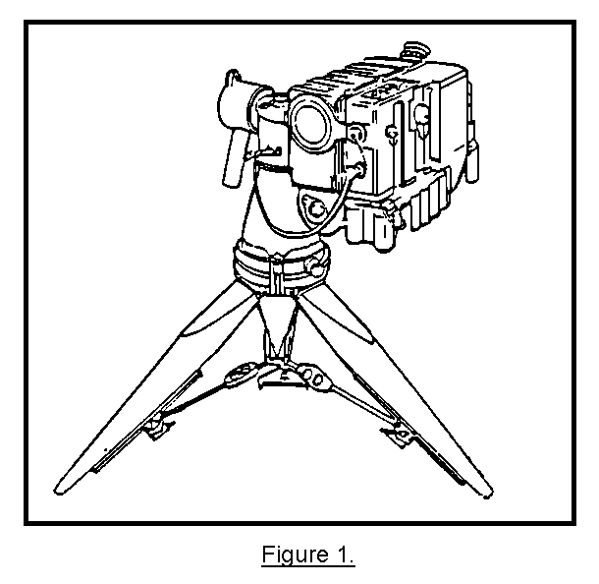
2. SIGHTING THE TARGET. As a locator, the G/VLLD can be used to determine distance, direction, and vertical angle to a target immediately after sighting the target in the G/VLLD eyepiece. When the G/VLLD operator sights a target, the instrument shoots out a narrow, powerful beam of light called a laser. As the laser hits the target, the G/VLLD automatically gives the operator a very accurate target location. With an effective range of 10 kilometers, the G/VLLD can supply the operator with a target location to the nearest 10 meters. When using the designator function, the G/VLLD sends a constant laser toward the target. With this function, the G/VLLD operator holds the target centered in his eyepiece. This allows guided artillery shells such as Copperhead and Hellfire to seek the laser spot on the target and destroy it (Figure 2). With adequate planning, an experienced FO can designate a whole column of armored vehicles and one-by-one score a direct hit every time. For the FO that really knows how to use the G/VLLD, one Copperhead round equals one destroyed tank.
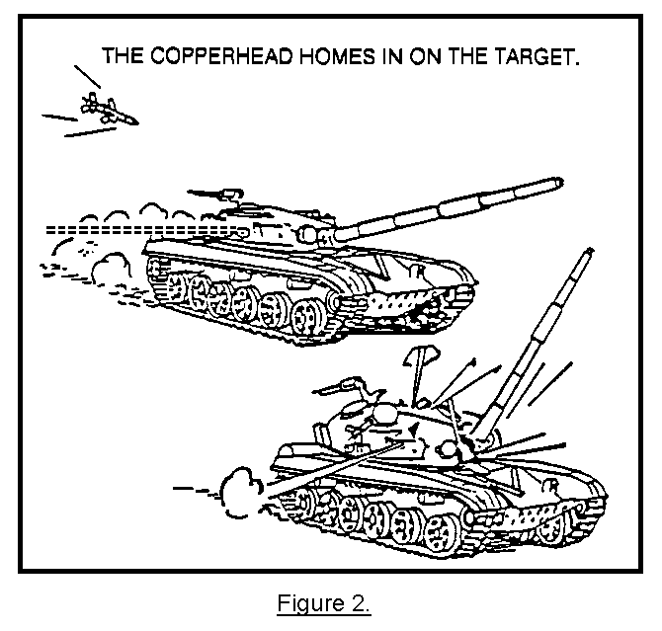
3. UNPACKING AND SETTING UP THE TRIPOD.

a. When the G/VLLD is being transported, it will be broken down into two sections and stored inside two protective backpacks. One contains the tripod/traversing unit and the other houses the laser portion of the G/VLLD, the laser designator/rangefinder (LD/R) (Figure 3). The tripod/traversing unit is simply an adjustable tripod with an assembly on top that swivels from side to side and up and down so that the operator can track a target with the LD/R.
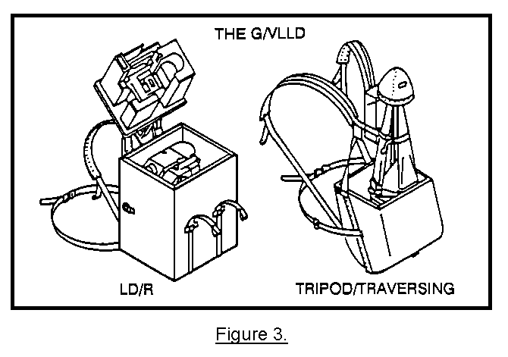
b. The first step in unpacking and setting up the tripod/traversing unit is to remove the tripod from the backpack. You will unbuckle the hood and leg straps and store them in the backpack. Then you will have to carefully lift the tripod/traversing unit from the backpack. Look at Figure 4 to get a better idea.
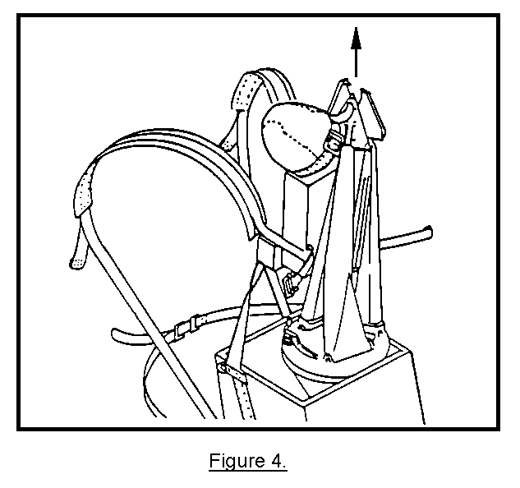
(1) To remove the tripod/traversing unit from the backpack, perform the following:

• Unbuckle the hoods and leg straps.

• Lift the tripod/traversing unit out of the backpack, and hold the unit in one hand.

• While still holding the tripod with one hand, locate the three wing nuts. There is one wing nut on each of the legs of the tripod. Loosen the wing nuts by turning them counter-clockwise. With all three wing nuts loosened, you will be able to pull each leg outward until the leg clamps lock in place (Figure 5).

(2) To open the tripod/traversing unit legs, perform the following:

• Hold the tripod upright in one hand.

• Loosen each wing nut on the three tripod legs.

• Pull outward on each leg until the leg clamps lock in place, then you can set up the tripod.
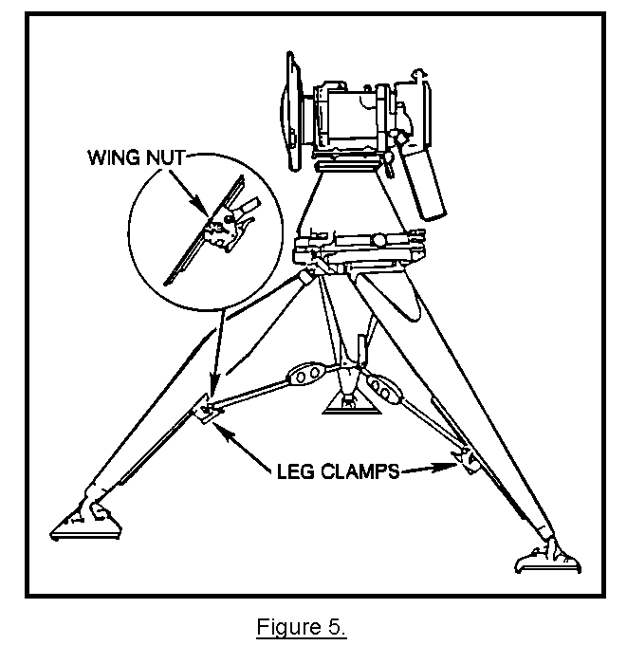
(3) To position the unit, perform the following:

• Now that the tripod legs are extended, place the unit on the ground with the leg marked "DOWNHILL LEG" pointing toward your sector of fire (downrange). The handgrip and the AZ
ADJ knob should be facing opposite the DOWNHILL LEG. Obviously if they are not, you would have to reposition the tripod unit. By pointing the DOWNHILL LEG downrange, this will position the traversing unit controls where you can reach them. These two controls are the azimuth gimbal lock and the elevation gimbal lock. These controls lock the traversing unit into place until you need to swivel the unit from side to side or up and down.

• Locate the azimuth gimbal lock, and loosen the lock by turning it counterclockwise.

• Rotate the traversing unit until the handgrip is pointing in the proper direction, and tighten the gimbal lock (Figure 6).

• Rotate the traversing unit by loosening the azimuth gimbal lock and turning it counterclockwise.

• Rotate the traversing unit until the handgrip is facing opposite the DOWNHILL LEG.

• Now, tighten the azimuth gimbal lock until it is finger tight. Now, the handgrip and the AZ ADJ knob are opposite the DOWNHILL LEG.

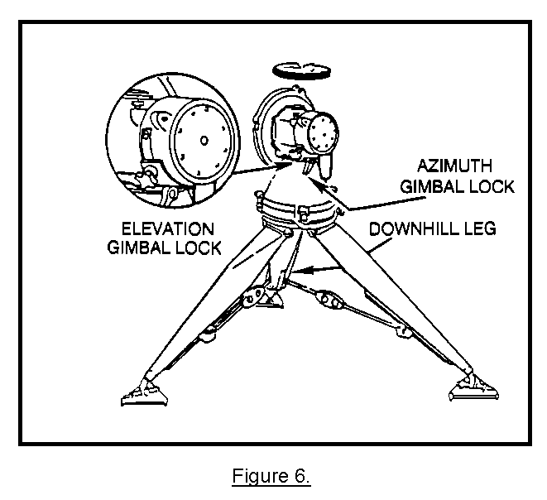
- Now that the tripod unit has been positioned, you have one last step before the LD/R can be installed. The tripod/traversing unit must be coarse leveled. To coarse-level the tripod/traversing unit, perform the following:

Note: Center turnbuckle assemblies before coarse leveling to ensure adequate turnbuckle adjustment during fine leveling.

• Locate the bubble level on top of the traversing unit (Figure 7).

• Starting with one of the uphill legs, press down on the leg detent lever and adjust the leg while watching the floating bubble.

• Free the bubble from the sight glass wall, and float the bubble toward the center of the sight glass.

• Now, press down on the detent lever on the DOWNHILL LEG.

• Adjust the leg until the bubble is roughly centered in the sight glass.

• Tighten the wing nuts.

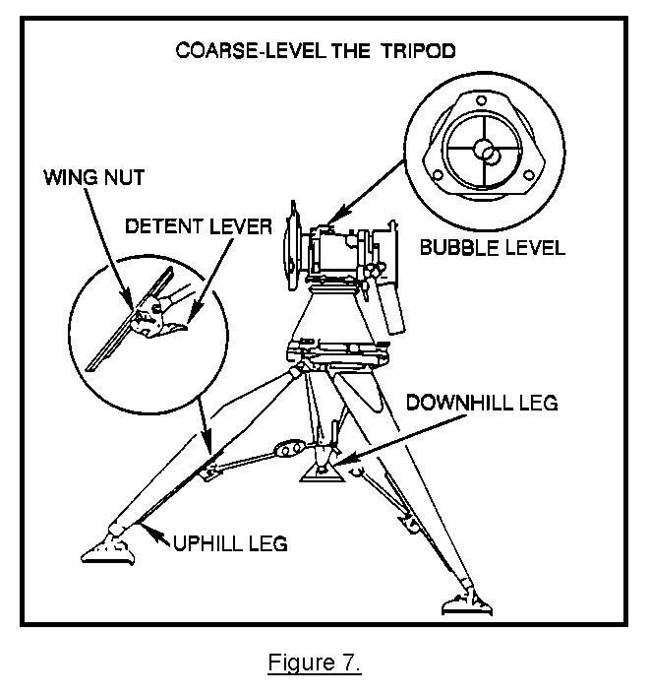
PRACTICE EXERCISES:

Complete the following exercises by circling T for true or F for false, circling the letter preceding the correct answer, or filling in the blanks, as appropriate. Be sure to complete the practice exercises as they appear. They are "building blocks" and will help you complete the rest of the subcourse successfully. The answers follow the last. If any of your answers are incorrect, restudy the appropriate part of the subcourse before you continue.

In the following illustrations, you will be shown a picture of the traversing unit that has not been completely set up. Select the next step in each picture for setting up the tripod.

1. Look at the illustration below. You can see the tripod has been removed from the backpack. What is the next step in setting up the tripod?

a. Press down on the detent levers.
b. Install the LD/R onto the tripod/traversing unit.
c. Loosen the wing nuts on the tripod legs.
d. Tighten the azimuth gimbal lock.
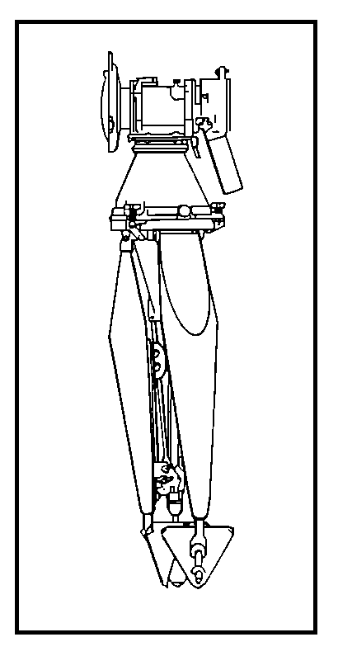
2. In the illustration below, what is the next step the operator must perform before coarse-leveling the tripod?

a. Turn the tripod so the DOWNHILL LEG is pointing toward the sector of fire downrange.
b. Turn the tripod so that the DOWNHILL LEG is facing opposite the sector of fire.
c. Move the tripod so it is facing away from the sector of fire.
d. Turn the tripod so the DOWNHILL LEG is pointing uphill.
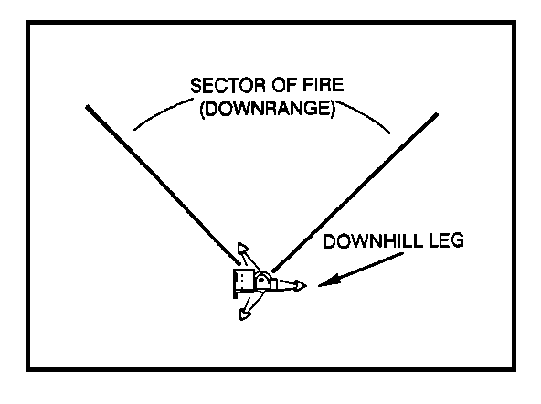
3. The handgrip is pointing down, but in the wrong direction. What must you do to position the handgrip opposite the DOWNHILL LEG? (See next illustration below.)

a. Loosen the elevation gimbal lock, and position the handgrip to the proper position.
b. Release the detent levers, and press down on the handgrip.
c. Loosen the azimuth gimbal lock, and rotate the traversing unit until the handgrip is facing the proper direction.
d. Pick the tripod/traversing unit up, and turn it around until the handgrip is pointing in the right direction.

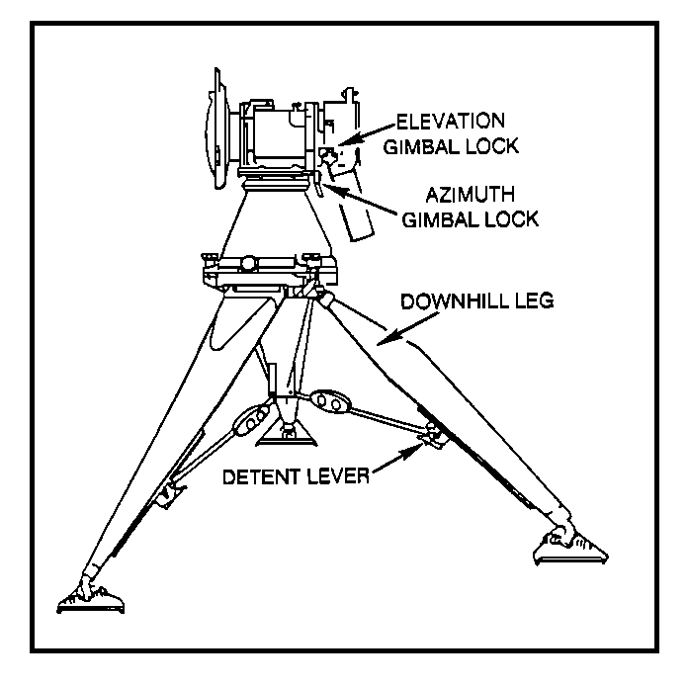
4. In the illustration below, the tripod/traversing unit is being coarse-leveled. The air bubble has been centered on the hairline, but the tripod still is not level. What must be done to coarse-level the tripod/traversing unit?

a. Pick the tripod up, and center the air bubble by moving the tripod back and forth.
b. Adjust the DOWNHILL LEG by pressing down on the leg detent lever until the air bubble is centered in the sight glass.
c. Loosen the elevation gimbal lock, and turn the traversing unit until the air bubble slides into the center of the sight glass.
d. Adjust one of the uphill legs by pressing down on the leg detent lever until the air bubble is centered in the sight glass.
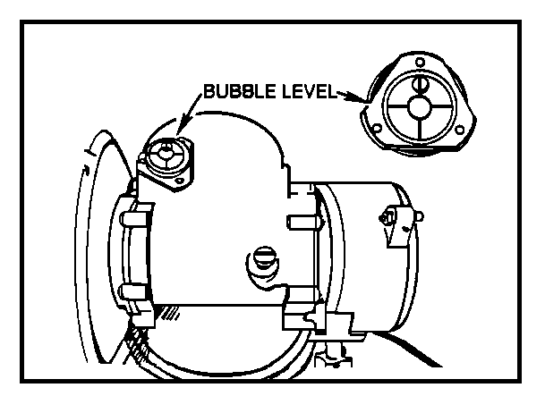
ANSWERS:

1. c.
2. a.
3. c.
4. b.

4. UNPACKING AND SETTING UP THE LASER DESIGNATOR/RANGEFINDER. In paragraph 3, we unpacked and set up the tripod. Now, the LD/R can be installed on the tripod.
The LD/R operates on a powerful nickel-cadmium (NICAD) battery installed on the bottom of the LD/R. When the laser trigger is pulled, the LD/R will fire the laser beam (Figure 8). Like the tripod/traversing unit, the LD/R is a precision instrument and must be handled carefully to keep from dropping it or damaging the lens and the eyepiece. Unpacking and installing the LD/R on a tripod unit may look like a very simple operation, but do not rush the job by taking shortcuts. To keep from damaging the LD/R or accidentally pulling the trigger, just follow the few precise steps for unpacking, installing, and securing the LD/R and for connecting the interface cable.
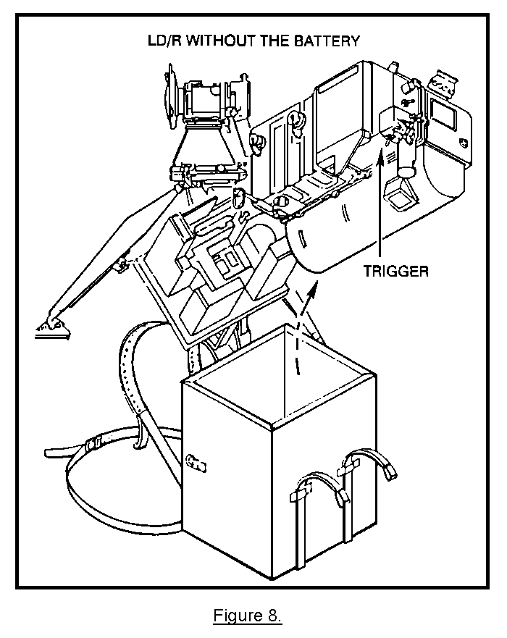

CAUTION

DO NOT LIFT THE LD/R BY THE EYEPIECE.

a. To unpack and install the LD/R, perform the following steps (see Figure 9):

• Open the LD/R backpack by unbuckling the two straps.

• Reach down, and rotate the LD/R handgrip down so you can grasp it with your left hand.

• Grasp the handgrip, and pull upward until you can get your right hand under the right-front edge of the LD/R.

• Keeping your fingers off the laser trigger, use both hands to lift the LD/R out of the backpack.

• Continue to hold the LD/R by the right-front edge and the handgrip.
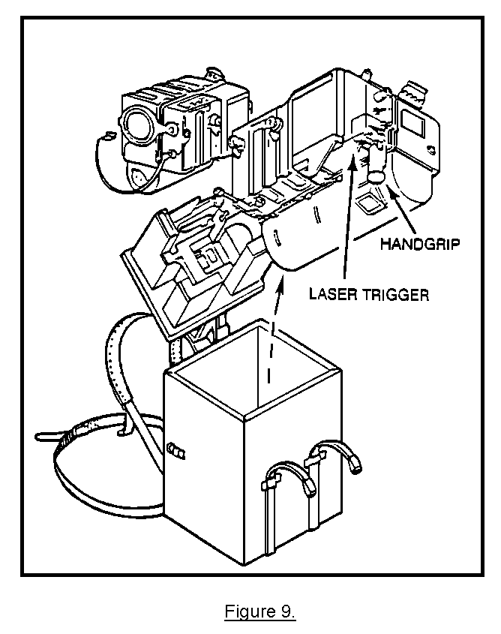
• Still holding the LD/R in your hands, carefully mount the LD/R on the tripod/traversing unit.

• When you are mounting the LD/R, align the index pin with the index pin notch (located on top of traversing unit) (Figure 10).

• Guiding the pin into the notch, hook the LD/R mount to the upper part of the traversing unit mounting flange (Figure 10).

• Locate the index pin notch, and align the pin with the notch.

• Hook the LD/R mount on the upper part of the traversing unit mounting flange.

• Engage the index pin into the traversing unit index pin notch. The LD/R is now mounted on the tripod/traversing unit. Now you must secure the LD/R.
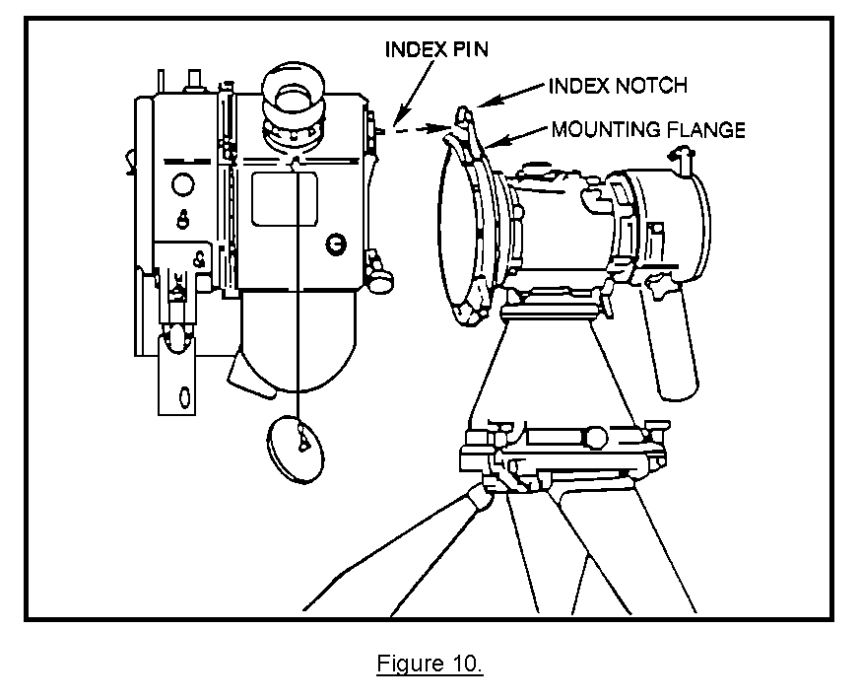
b. To secure the LD/R to the traversing unit, perform the following:

• Center the swing bolts (Figure 11) over the notches on the traversing unit.

• Unscrew the bolts by turning them counterclockwise until the bolts can slip into the notches on the tripod/traversing unit.

• Push the swing bolts into the notches, and tighten the bolts until finger tight.

Now that the LD/R is secured to the tripod/traversing unit, you will have to electrically connect the LD/R to the traversing unit.

c. To connect the interface cable, perform the following (Figure 11):

• Remove the cover from the 1J2 connector on the front of the LD/R by unscrewing it counterclockwise.

• Stow the cover on the dummy connector.

• Take the traversing unit interface cable, and screw it on the 1J2 connector until finger tight.
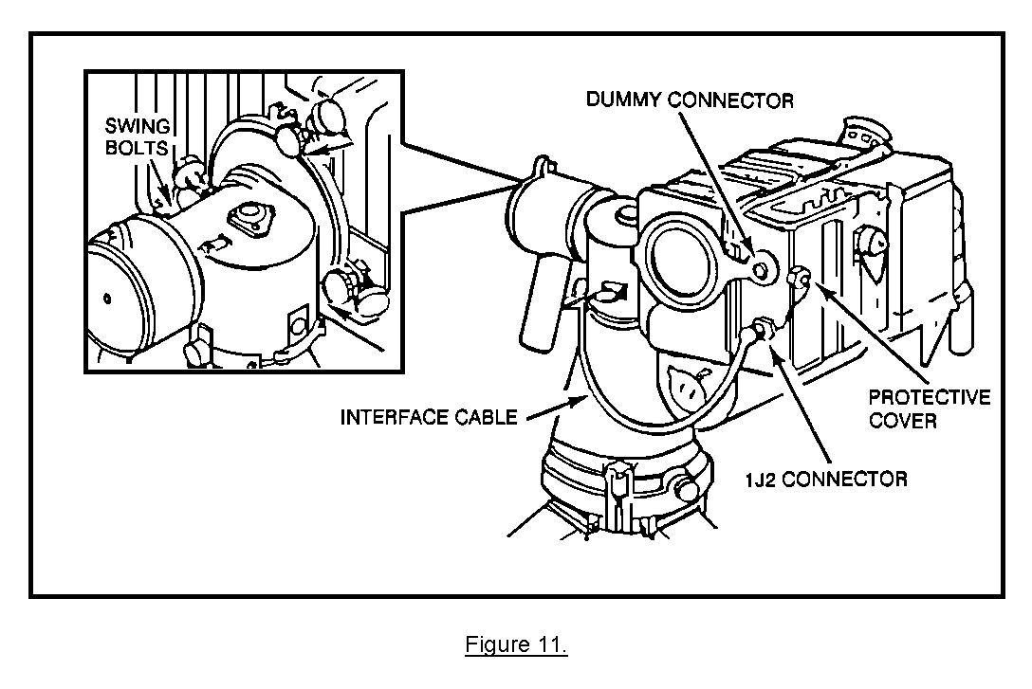
d. To fine-level the unit, perform the following (see Figure 12):

• Place a sandbag over each tripod leg footpad to prevent the G/VLLD from tipping.

• Loosen the azimuth gimbal lock.

• Grasp the LD/R handgrip, and rotate the LD/R over the DOWNHILL LEG so that the laser lens faces to the right of the DOWNHILL LEG. This helps stabilize the G/VLLD.

• Tighten the azimuth gimbal lock.

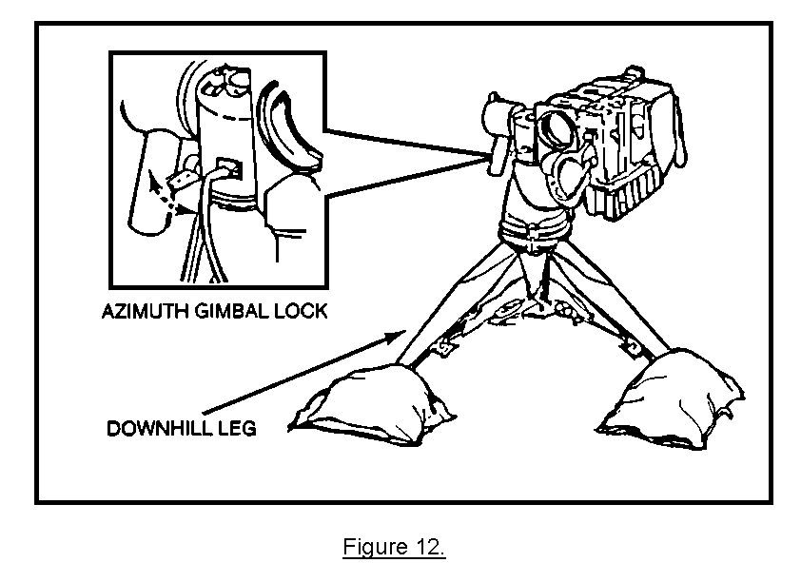

• Starting with the DOWNHILL LEG(3), adjust the three turnbuckles(2) so that the bubble level(1) is centered. (see Figure 12a)

Figure 12a.

PRACTICE EXERCISES:

5. By looking at the illustration below, select the next step in the procedure for unpacking and installing the LD/R from the choices provided.

a. Connect the interface cable.
b. Engage the index pin into the index pin notch.
c. Tighten the elevation gimbal lock.
d. Position the LD/R handgrip upward.

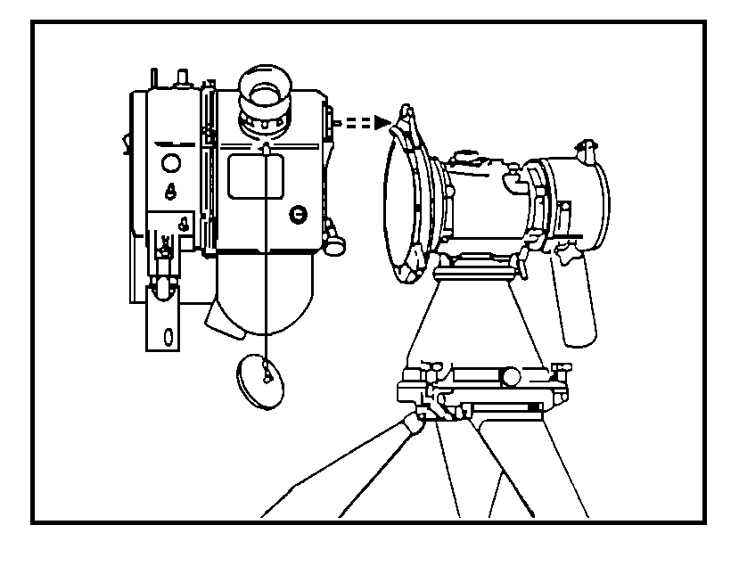
6. When lifting the LD/R out of the backpack, you must grip which of the following parts with your left hand to lift?

a. the eyepiece
b. the LD/R handgrip
c. the interface connector
d. the laser trigger
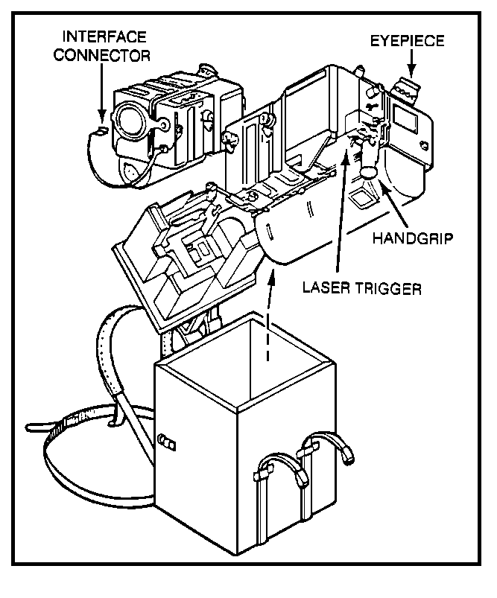
ANSWERS:

5. b.
6. b.

5. SUMMARY. The unpacking and installation of the tripod and the LD/R require a great deal of common sense. We have learned that by pointing the DOWNHILL LEG downrange, you will be able to reach the traversing unit controls. Also, like most precision instruments, it must be level before use. This is called coarse leveling. Further, we learned that the handgrip and AZ ADJ knob should be facing opposite the DOWNHILL LEG. Finally, when lifting the LD/R out of the backpack, you must not lift it out by the eyepiece. Always use both hands to lift the LD/R from the backpack, being careful not to pull the laser trigger located at the base of the handgrip, since it is possible to fire the laser in this position.

LESSON 2

PERFORM THE OPERATIONAL TEST ON THE AN/TVQ-2 G/VLLD

OBJECTIVE

Upon completion of this lesson, you will be able to perform the operational test on the AN/TVQ-2 G/VLLD.

REFERENCES

This lesson is based on FM 6-30 and other materials approved for US Army field artillery instruction; however, development and progress render the text continually subject to change. Therefore, base your examination answers on material presented in this subcourse rather than on individual or unit experience.

6. INTRODUCTION. In the previous lesson, you learned how to unpack, set up, and coarse-level the tripod traversing unit. Also, you learned how to unpack and install the LD/R. Now it is time to learn how to operate the equipment in an accurate and/or safe manner. The good observer should always strive for perfection when operating the G/VLLD.

7. PERFORMING THE INITIAL CHECKS. There are a few simple checks that you must perform before using the G/VLLD.

WARNING

THE LASER BEAM CAN CAUSE SERIOUS INJURY IF YOU ARE SHOT DIRECTLY IN THE EYES OR IF IT IS REFLECTED FROM A SHINY SURFACE INTO THE EYES. WHEN YOU ARE INSPECTING THE LASER WINDOW, TAKE THE SAME PRECAUTIONS AS IF YOU WERE LOOKING DOWN THE BARREL OF A LOADED WEAPON TO INSPECT THE LASER WINDOW SAFELY, MAKE SURE THAT THE POWER SWITCH IS OFF AND THEN LOOK AT THE LENS FROM A ANGLE NEVER LOOK DIRECTLY INTO THE LASER WINDOW.

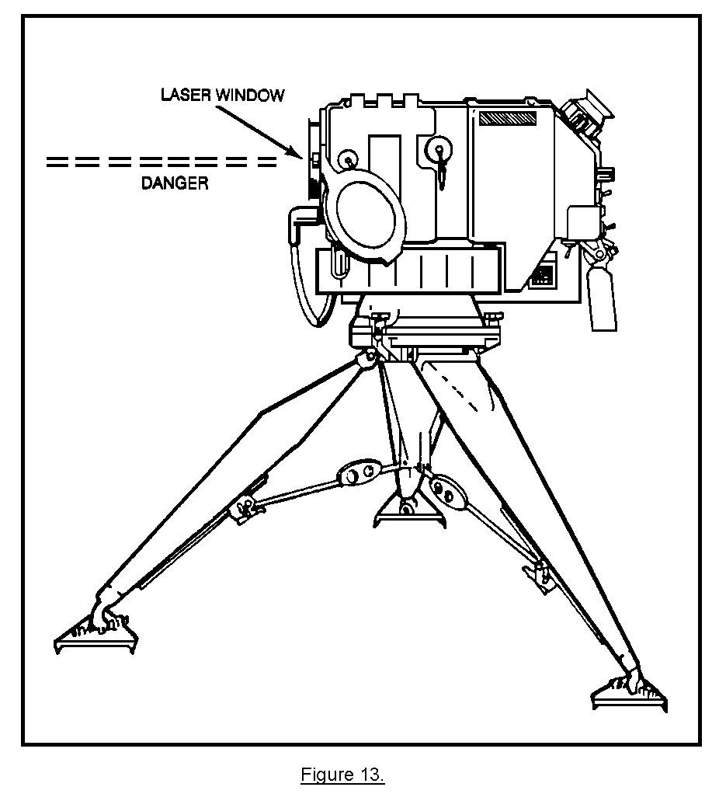
a. The first component you inspect when performing your initial checks is the laser window (Figure 14). After making sure that the LD/R power switch is off, you remove the window protective cover and inspect the window from an angle. Never look directly into the laser window. Remember, the laser causes eye damage if you are shot directly in the eyes. If the lens are dirty, you have to clean them with lens paper and cleaning solution.
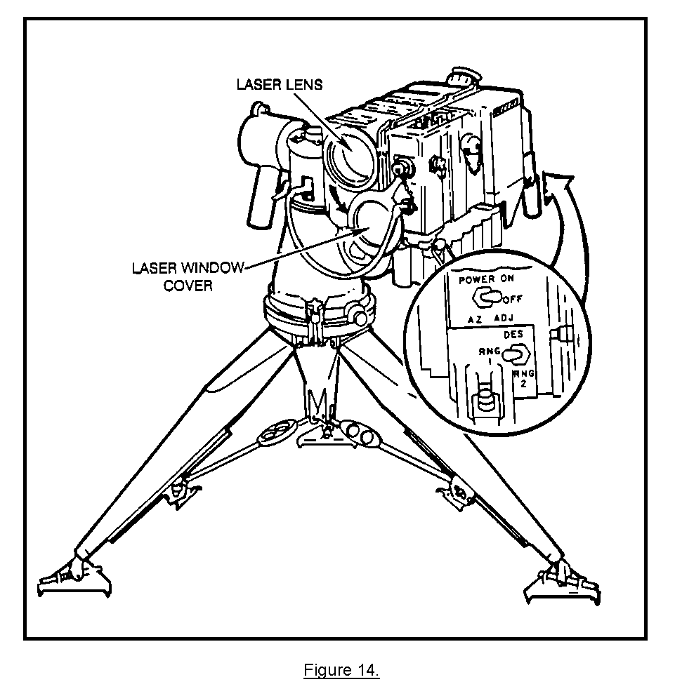
(1) To clean the lens without scratching it, use a special cleaning solution, lens cleaning tissue, and lens dusting brush. All the items you need come in a lens cleaning kit that is stored inside the lid of the LD/R backpack (Figure 15).
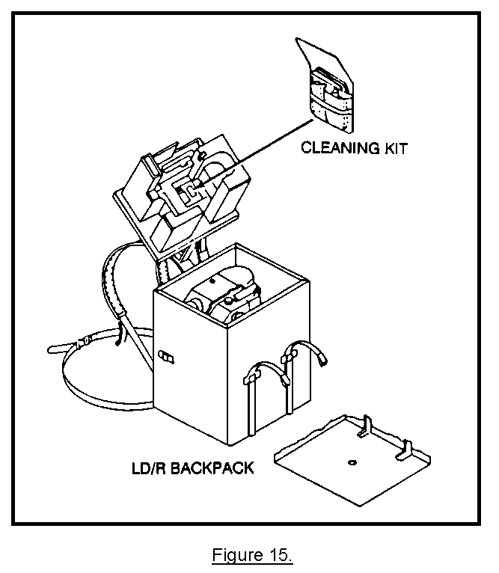
(2) You will remove dirt, grit, and lint from the lens, and then cover the laser window again once the lens is clean. (See Figure 16.)
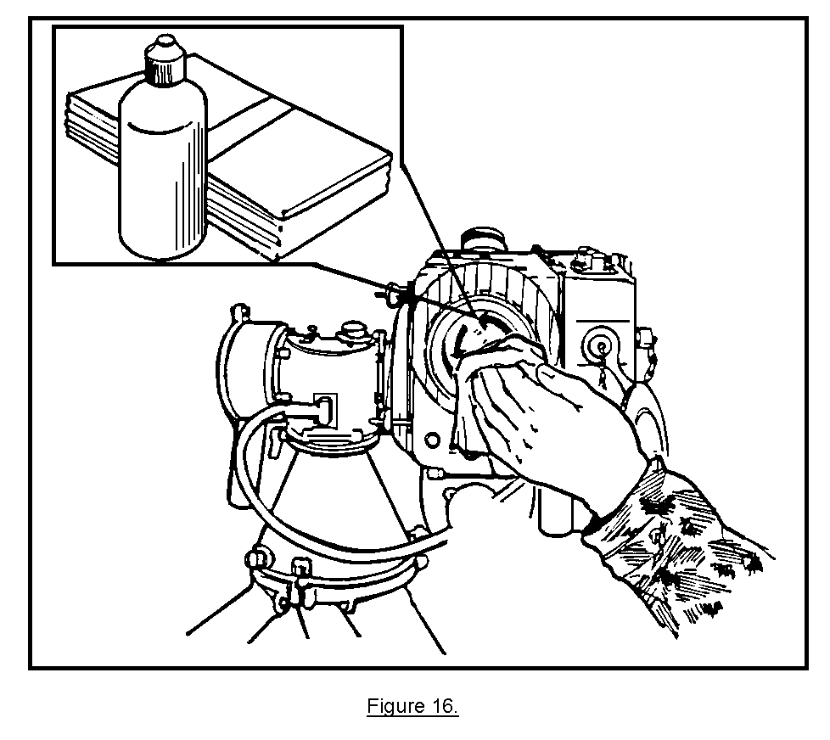
b. After cleaning the laser window, you inspect and clean the LD/R eyepiece. Just as you did with the laser window, you remove the protective eyepiece cover and inspect the eyepiece lens (Figure 17). If they are dirty, clean them in the same manner as you did with the laser window.
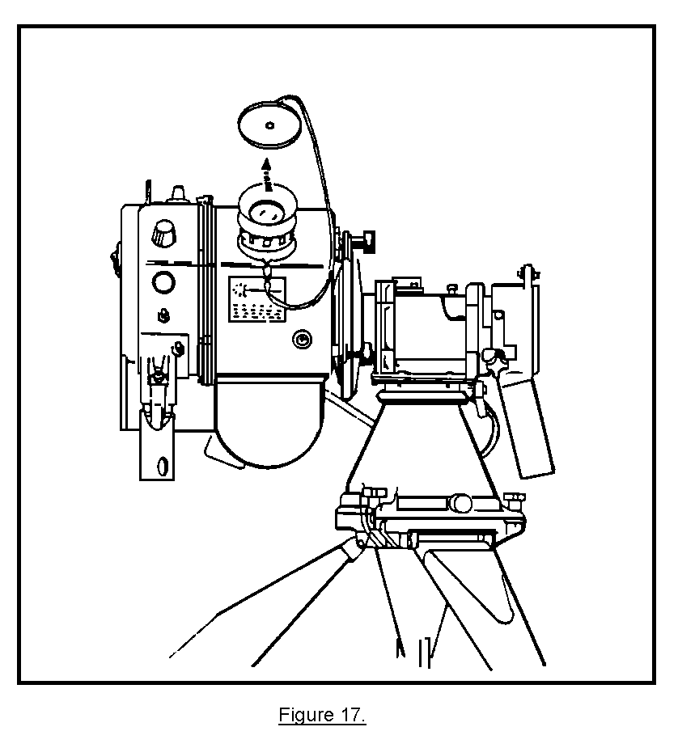
c. After inspecting and cleaning the lenses on the LD/R, you inspect the traversing unit. The first step is to inspect and clean the bubble level. The G/VLLD should already be fine-leveled, but you may have knocked it out of level while you were cleaning the lenses. If the G/VLLD is out of level, you adjust the center turnbuckles on the tripod until the air bubble is back in the center of the sight glass. Once the G/VLLD has been fine-leveled, you ensure that the elevation and azimuth gimbal locks are serviceable and finger tight. This locks the LD/R into position while you finish your inspection. (See Figure 18.)
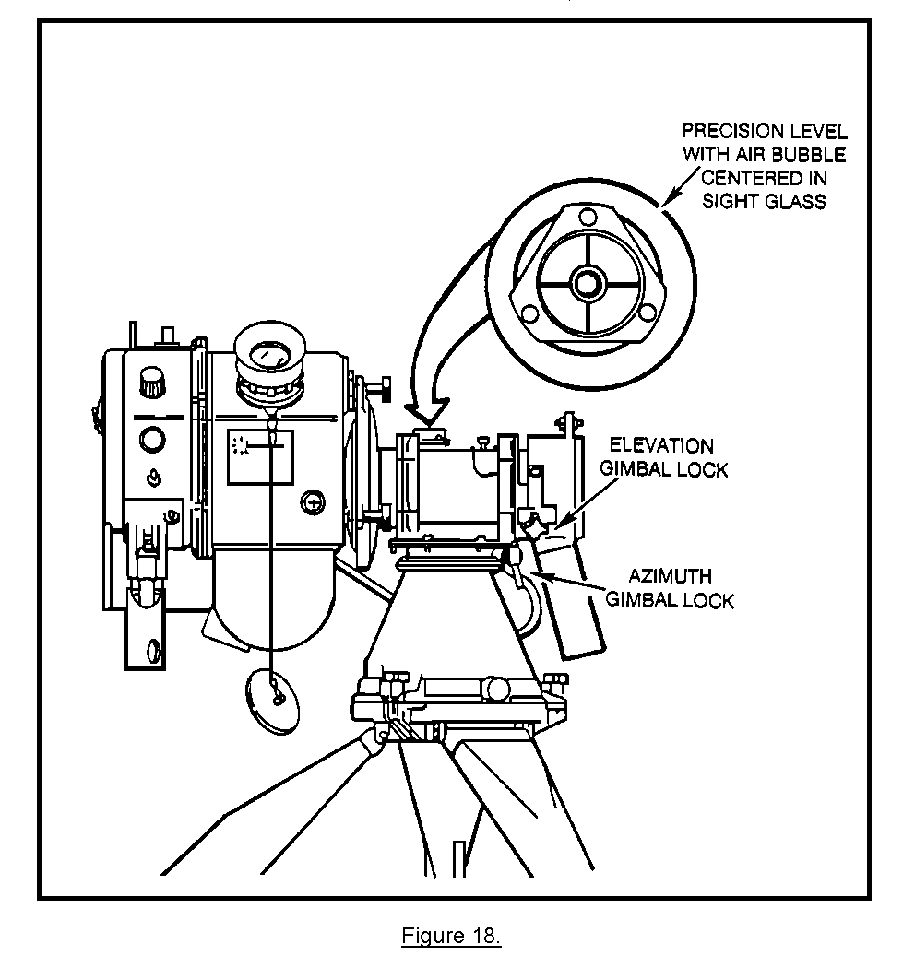
PRACTICE EXERCISES:

7. Before inspecting the laser window, which of the following safety recautions must the operator observe? Look at the next illustration.

a. The laser window protective cover must be emplaced on the laser window.
b. The AZ ADJ knob should be set to the OFF position.
c. The LD/R POWER switch must be set to the OFF position.
d. The battery should be removed from the LD/R.
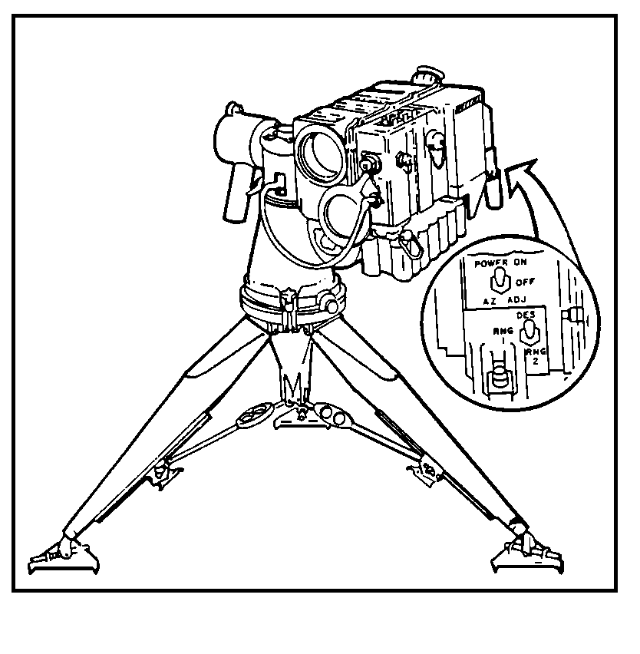
8. In the illustration below, the G/VLLD has been knocked out of level, what should the operator do to fine-level the G/VLLD again?

a. Adjust the center turnbuckles.
b. Press down on the tripod detent levers.
c. Tighten the elevation and azimuth gimbal locks.
d. Pull the traversing unit handgrip down.
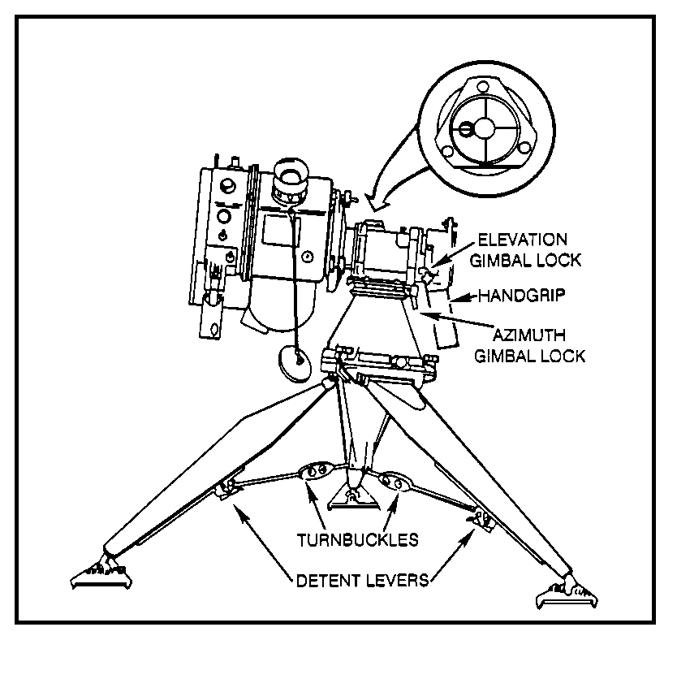
ANSWERS:

7. c.
8. a.

8. READOUTS AND RETICLE PATTERN.

a. Take a look at Figure 19. The left readout shows azimuth (AZ) values from 0000 to 6399 mils. The range (RNG) readout in the middle indicates the line-of-sight (LOS) distance in meters from the G/VLLD position to a target. The readout has four digits and gives range values to the nearest 10 meters when the LD/R is operating in the RNG 1 and RNG 2 modes. The elevation (EL) readout on the right shows the location of a target above or below the G/VLLD position (vertical angle). Elevation has four readout values from 444 to -400 mils. The fourth digit on the left shows the minus sign if one is necessary.

b. The three small colored indicator lights monitor important LD/R conditions. The red light on the left indicates laser failure. It will blink if the laser is overheating. It also lights and stays on to indicate a different problem--low laser power output. As long as the laser is working properly, the red light indicator does not light up. The amber light on the right also is a warning that indicates low voltage in the LD/R NICAD battery. The green light in the middle indicates a command signal from the fire direction center. It lights
and stays on to tell you when to fire the laser in the designate mode. The fire
command is received by a digital message device (DMD) connected to the LD/R.
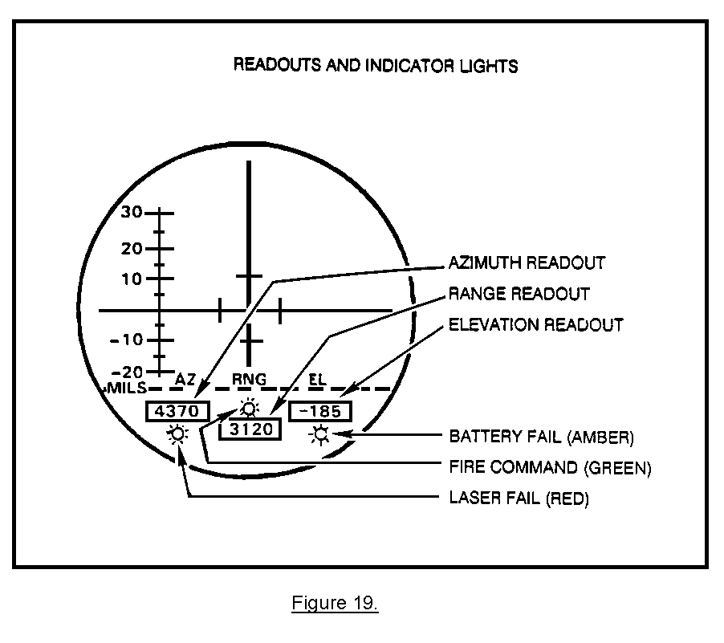
c. The upper portion of the eyepiece display is the reticle, the area where you view terrain and targets. The reticle has a pattern of lines on it. The intersection of the two cross hairs provides an aiming reference. The center of the reticle indicates the line of sight of the laser beam. The vertical and horizontal cross hairs are graduated in 10-mil increments. To get a better idea, look at Figure 20.
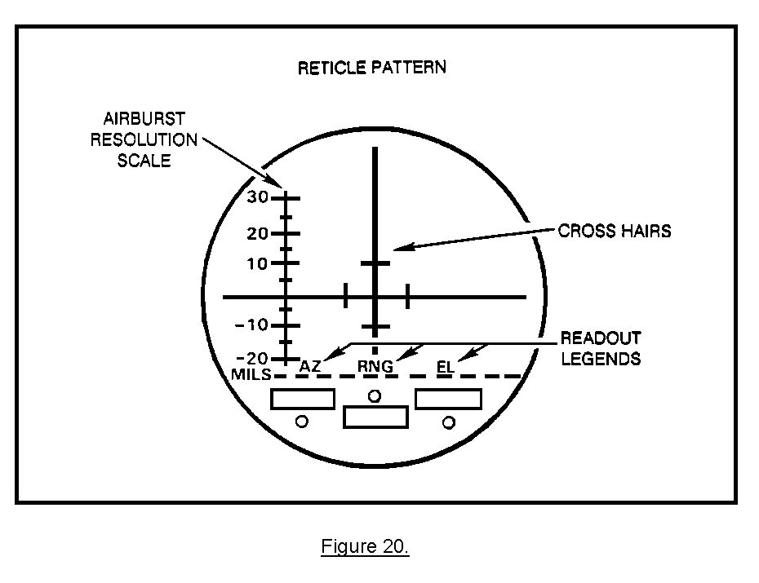
At the left edge of the reticle pattern is an airburst resolution scale. (You will not use it in this lesson.) Just above the display readouts are the legends AZ, RNG, and EL. They identify the number displays.

9. CONTROLS AND SWITCHES. You will use six controls and switches on the LD/R
in performing the various steps on the self-test (Figure 21).

a. Mode selector switch. This switch is used to select any one of three modes of laser operation. It has three positions: DES (designate mode), RNG 1 (ranging mode for soft targets), and RNG 2 (ranging mode for hard targets). During the LD/R self-test, this switch is set to DES.

b. Power switch. This switch also has three positions. The ON position applies power to the LD/R. The OFF position turns the power off. AZ ADJ prepares the G/VLLD so you can adjust the azimuth readout to any desired reference azimuth. You will use the AZ ADJ position in the self-test just to check the illumination level of the display readouts.

c. RETICLE BRIGHT control. This control varies the illumination level of the reticle in the eyepiece display.

d. DISPLAY BRIGHT control. This control varies the illumination level o the display readouts and indicator lights. In the test position, it lights all readouts, indicator lights, and the reticle pattern so the operation of their electrical circuits can be tested.

e. Focus ring. This ring is located on the eyepiece. It allows you to focus the reticle.

f. Laser trigger. The laser trigger fires the laser. It is a spring-loaded toggle switch loaded under the rear portion of the LD/R body, just forward of the LD/R handle.

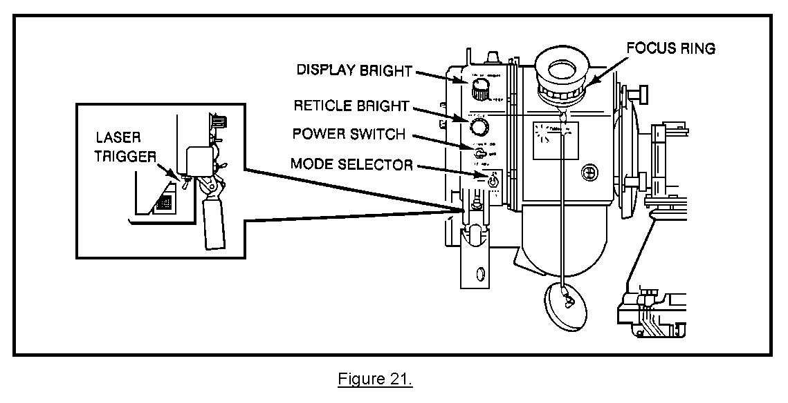
10. PREPARATION AND SELF-TEST. To prepare the LD/R for self-test, there are a
few things to do before starting.

• Rotate the LD/R handle downward until the release button locks the handle into position (Figure 22). If the handle does not lock into position, inspect the handgrip for obstructions or damage. Remove any obstruction, and again try to lock the handle in the down position.

• Set the mode selector switch to DES (Figure 21).

• Make sure the laser window cover is securely in place, and no one is standing in front of the G/VLLD.

• Set the POWER switch to the ON position (Figure 21). With the power on, the laser will fire if you pull the trigger.
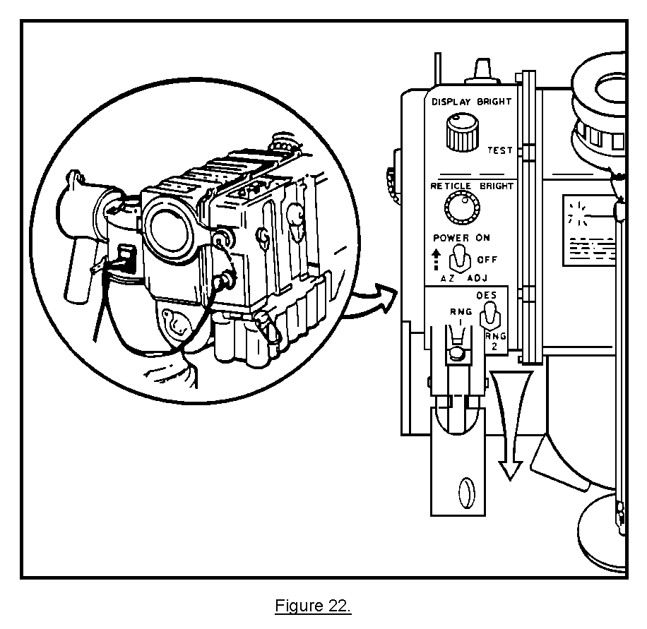
a. Testing the display readouts and indicator lights. With the power turned on, the LD/R is ready for the first important test. When you use the G/VLLD on a mission, readouts provide your locating data and the indicator lights warn you of problems with the functioning of the LD/R. But before that, you need to know if the readouts and indicators themselves are in working order. This step checks their circuits and tells whether they are receiving enough power to do their jobs. To test the display readouts and indicator lights, perform the following:

• Turn the DISPLAY BRIGHT control to the TEST position (Figure 23).

• Turn the knob fully clockwise until it clicks.

• Look into the eyepiece display.

• Observe that the reticle pattern lights up.

• Check that the red, green, and amber lights also illuminate.

• Look at the three numerical display readouts (Figure 23).

- The AZ readout must show illuminated 8888.
- The RNG readout must show illuminated 8888.
- The EL readout must show illuminated -888.

• If the reticle indicator lights and readouts do not light up, replace the LD/R battery. Then repeat the test. If any part of the display still fails to illuminate, replace the LD/R.
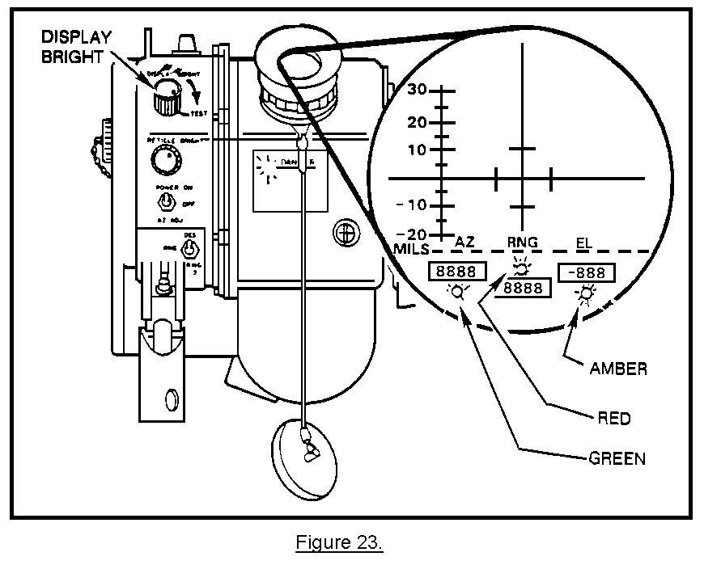
b. Adjusting the reticle and readout numbers brightness.

(1) Reticle. To adjust the reticle, perform the following:

• Remove the laser window cover. Look into the eyepiece again.

• With the DISPLAY BRIGHT control still in the TEST position, turn the RETICLE BRIGHT control clockwise to adjust the reticle to the desired-illumination level.

NOTE: The RETICLE BRIGHT control will brighten or darken the reticle pattern. It will not change the level of illumination of the display readouts or indicator lights.

• Turn the focus ring until both the reticle and distant objects are in focus. The terrain and objects that you can see in the eyepiece should be clear and sharp (Figure 24).

• If reticle brightness or focus cannot be adjusted, replace the LD/R.
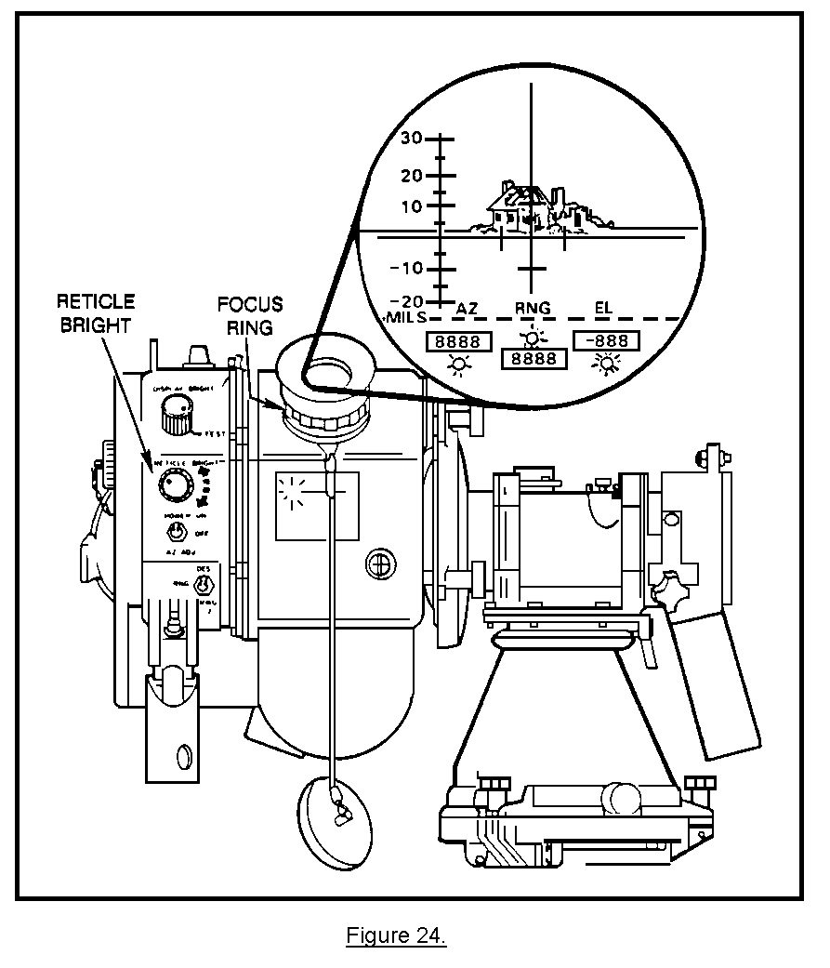
(2) Readout numbers. In paragraph a, you already checked that the display readout circuits work. Now, you must adjust the brightness of the readout numbers. To adjust the brightness of the readout numbers, perform the following:

• Turn the DISPLAY BRIGHT control off the TEST position.

NOTE: The eights disappear, and the readouts go blank. By using the POWER switch, you can make numbers appear again in the readouts.

• Hold down the POWER switch on the AZ ADJ position. This causes numbers to reappear again in the readouts.

NOTE: The POWER switch is spring-loaded away from the AZ ADJ position; therefore, continue holding the switch down as you adjust the light level.

• Use the DISPLAY BRIGHT control to adjust the readouts brightness.

NOTE: In the AZ ADJ setting, the AZ EL readouts will show real directional values in relation to the previous reference azimuth set on the G/VLLD. The RNG readout will show the distance of the previous laser ranging. (See Figure 25.)
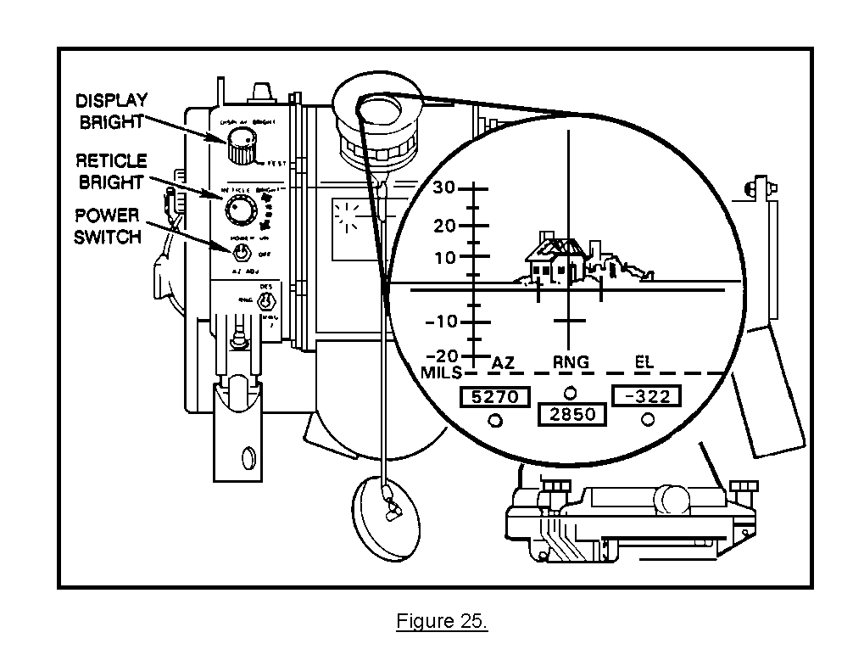
c. Adjusting the illumination level in the eyepiece. This is done by turning the DISPLAY BRIGHT control counterclockwise out of the TEST position. Notice the display readouts and indicator lights go off, but the reticle remains lit. Now, complete the adjustment by following the steps below:

• Set the POWER switch to the AZ ADJ position, and hold it down. Numbers appear in the readouts.

• Adjust the DISPLAY BRIGHT control clockwise and counterclockwise while holding the POWER switch on AZ ADJ. Observe the readouts brighten and then dim on the eyepiece display.

• Set the DISPLAY BRIGHT control to adjust the readouts to the desired level.

d. Testing the battery. To completely test the laser battery, you perform several visual and physical steps as follows:

• Release the POWER switch from AZ ADJ.

• Press the window cover firmly over the laser window. Observe all - laser safety precautions.

• Set the POWER switch to the ON position.

• Look into the eyepiece, and pull the laser trigger while you count to three.

• Note the three indicator lights. The green and amber lights should be off and should stay off. The red light should be off and stay off with the possible exception of a flash at turn-on.

• If the amber light comes on, replace the battery. With a charged battery installed, if any indicators still illuminate, replace the LD/R.

• Loosen the azimuth gimbal lock by turning it counterclockwise.

• Loosen the elevation gimbal lock by turning it counterclockwise.

e. Checking the laser performance. You already know the indicators work. Now fire the laser for three seconds, and observe the indicator lights.

(1) This step tests two things. Most important, it makes sure the LD/R can produce a sustained pulse of laser energy. At the same time, it checks the NICAD battery charge level. This extra battery check is necessary because the eyepiece display lights and circuits you tested earlier do not need much power. The battery might be strong enough to operate them, but not the laser.

(2) The LD/R will start this test with the indicator lights off. With the mode selector switch still set to the designate (DES) mode, you will observe all laser safety precautions as you fire the laser. If everything is working properly under normal conditions, the indicator lights will stay off. If a light does come on and stays on or blinks continuously, there is a problem. You must either change the battery or replace the LD/R.

11. PERFORMING THE AZIMUTH ZERO MODE TEST. The LD/R self-test that you performed checked to see if the display readout circuits were in working order. Now you can use the readouts to conduct a second test called the AZ zero mode test.

a. The AZ zero mode test checks the G/VLLD mechanisms for locating targets by measuring angles. It will determine whether the traversing unit correctly registers changes in azimuth and elevation and whether the LD/R accurately indicates those changes as AZ and EL readout values.

(1) The first part of the procedure will test the mechanism for setting the AZ readout to a selected reference azimuth. The G/VLLD must be able to do this so you can orient it to grid north. You will set the reference azimuth by turning the AZ ADJ knob (Figure 26) on the traversing unit. The AZ ADJ knob can change the setting of the AZ readout to any azimuth value.
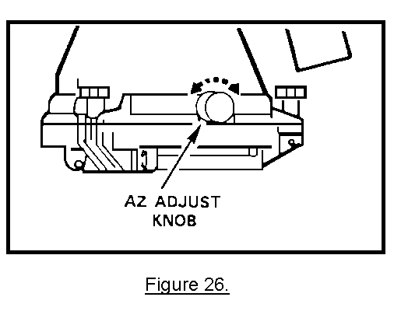
(2) The other two parts of the test are measurements of azimuth and elevation by the G/VLLD set on a reference object. First, you will ready the line-of-sight azimuth to an object. Then move the cross hairs 10 mils to one side of the object, and read the azimuth again. If the G/VLLD is working properly, the azimuth value in the readout will change by 10 mils. The test of the elevation reading works the same way. You will set the cross hairs on an object and note its elevation. Then move the cross hairs 10 mils below the point. The elevation value will decrease by 10.

b. The complete procedure for an AZ zero mode test on a G/VLLD that checks out okay is discussed below. If you do not get the required readout indications at each step, the G/VLLD is not working properly and must be replaced.

• Look into the eyepiece, and make sure the AZ, RNG, and EL readout digits are lit.

NOTE: The numerical values in the AZ, RNG, and EL readouts will be old readings. Ignore them in the above step. Just check that the readout digits are illuminated.

• Remove the laser window cover.

• Select a terrain feature or point as a reference object (Figure 27).

• Using an M2 compass, determine the azimuth from your position to
the reference object.

• Once you have the azimuth, use the AZ ADJ knob to change the AZ
readout to that value.

NOTE: Remember to hold the POWER switch in the AZ ADJ position the whole time
you are turning the AZ ADJ knob.
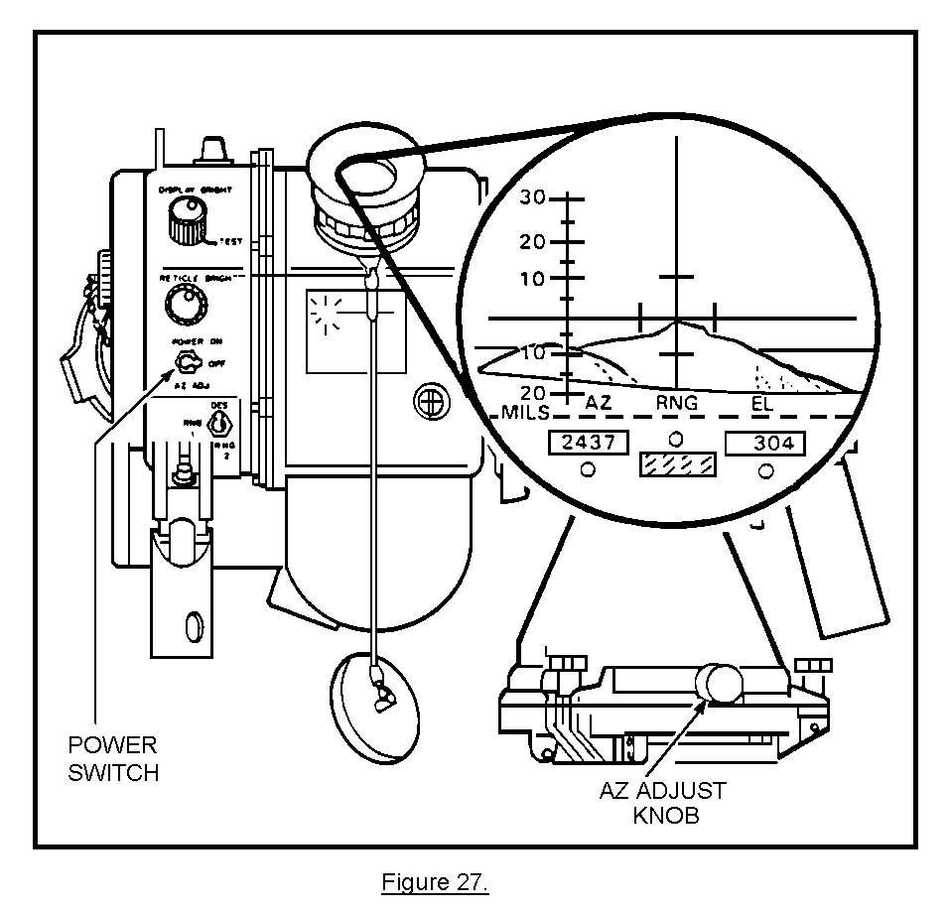
PRACTICE EXERCISES:

9. Looking at the illustration below, you have already determined from the AZ readout that azimuth to a target is 2,368 mils. What is the next operator action?

a. Move the cross hairs down until the upper 10-mil mark is on the target.
b. Rotate the AZ ADJ knob until the readout indicates 2368.
c. Move the LD/R to the left until the right 10-mil mark is on the target.
d. Hold the POWER switch in the ON position.
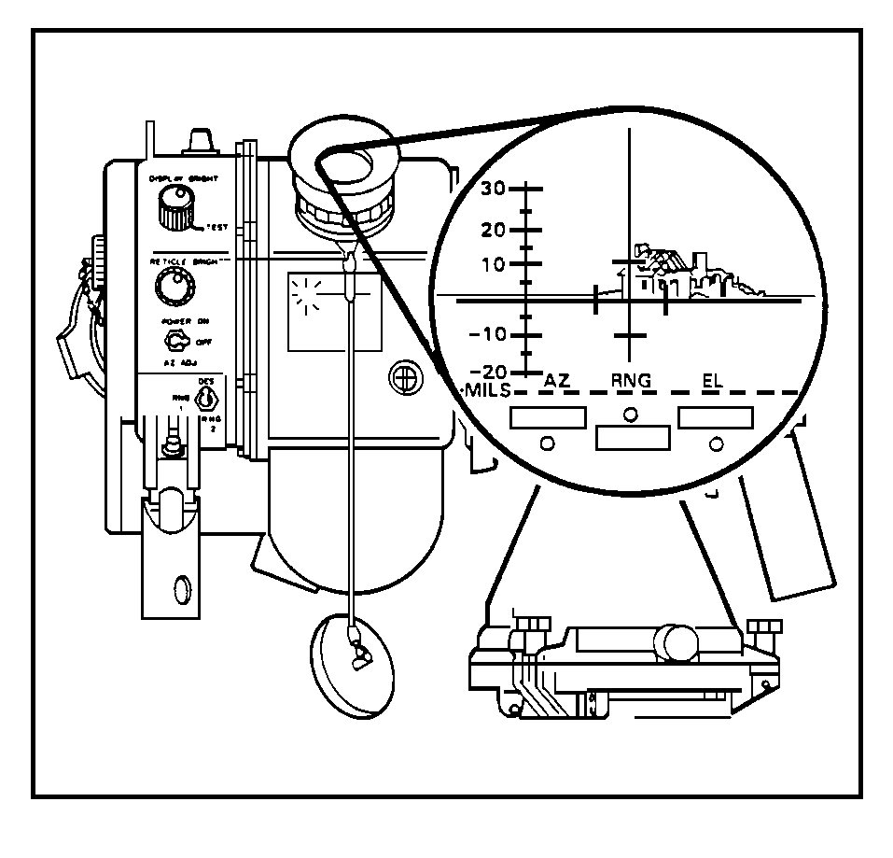
10. You are testing the operation of the elevation readout, and you have centered the cross hairs on the target as shown below. What is the operator's next action?

a. Note the EL readout value.
b. Hold the POWER switch to the AZ ADJ position, and note the readout value.
c. Rotate the AZ ADJ knob, and note the EL readout value.
d. Move the cross hairs down until the upper 10-mil mark is on the target.
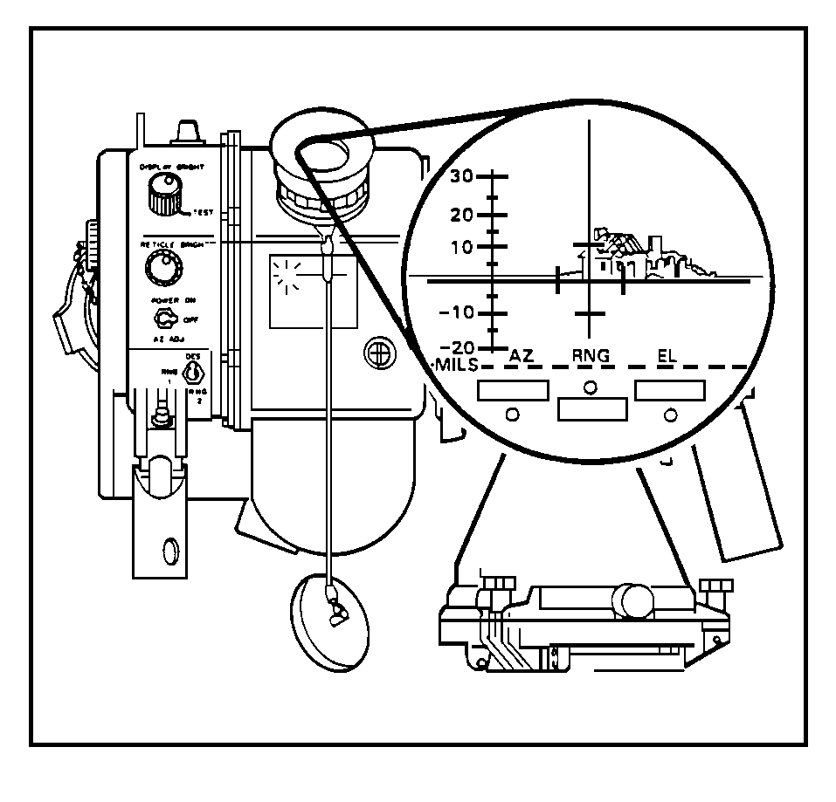
ANSWERS:

9. c.
10. b.

12. PLACING G/VLLD IN STANDBY-SHUTDOWN MODE. When the G/VLLD is not in use, you need to place it in a standby-shutdown mode. This prevents the G/VLLD from being damaged or knocked out of alignment while you are moving your observer position.

a. Remember, the G/VLLD is a precision instrument. If you knock it over or get dirt on the laser lens, you could seriously damage the G/VLLD. By placing the G/VLLD in a standby-shutdown mode, you can bring the G/VLLD back into action quickly without having to relevel the tripod or clean the lenses. Another important reason for placing the G/VLLD in a standby-shutdown mode is to protect you and your fellow soldiers from the laser. By turning the POWER switch off and covering the laser window, you not only save valuable battery power you also protect yourself in case someone accidentally pulls the laser trigger. With the POWER switch turned to the OFF position and covered by the LD/R handle, it is impossible for the laser to fire accidentally.

b. Once the power has been turned off and the protective lens covers have been installed, rotate the LD/R over the DOWNHILL LEG and secure it. Look at Figure 28 to get an idea how the G/VLLD looks in standby mode.
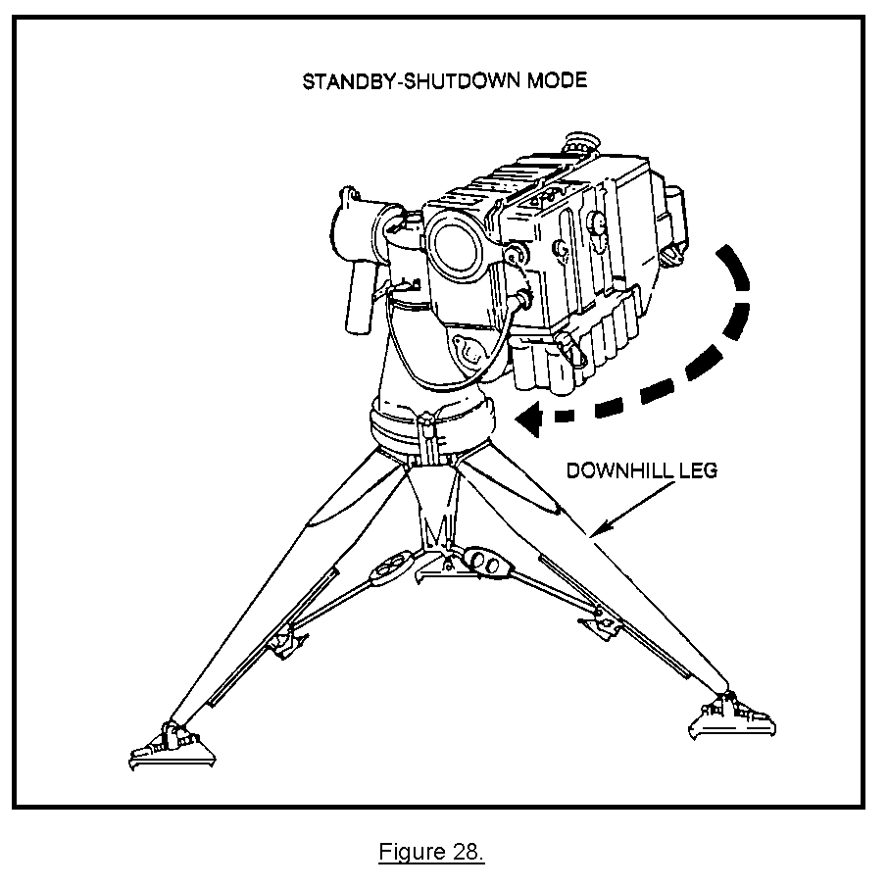
13. SUMMARY. In this lesson, we learned that during the initial checks it is important to keep the laser window clean and free of dust, since dust deflects laser light as it passes through the lens. When you are inspecting the laser window, never look directly into the window and make sure the POWER switch is off. Also, after you have fine-leveled the G/VLLD, ensure that the elevation and azimuth gimbal locks are serviceable and finger tight. Finally, when the G/VLLD is not in use, it should be placed in the standby-shutdown mode to prevent damage to it during movement to another position. Remember, an FO is only as good as the piece of equipment he uses and maintains properly.

LESSON 3

INSTALL THE AN/TAS-4B THERMAL NIGHT SIGHT

OBJECTIVE

Upon the completion of this lesson, you will be able to install the AN/TAS-4B thermal night sight.

REFERENCES

This lesson is based on FM 6-30 and other materials approved for US Army field artillery instruction; however, development and progress render the text continually subject to change. Therefore, base your examination answers on material presented in this subcourse rather than on individual or unit experience.

14. INTRODUCTION. On the modern battlefield, the fighting does not stop when the sun goes down, quite the contrary, the Threat forces are equipped with elaborate night vision devices to enhance their capabilities to locate and destroy targets at night. For that purpose, the G/VLLD comes equipped with a thermal night sight. This instrument is a passive infrared (IR) device that operates by detecting the differences in temperature between the target and the surrounding area. It then displays the difference as a visual image. Figure 29 shows the G/VLLD assembled and the night sight separate at the bottom of the picture.
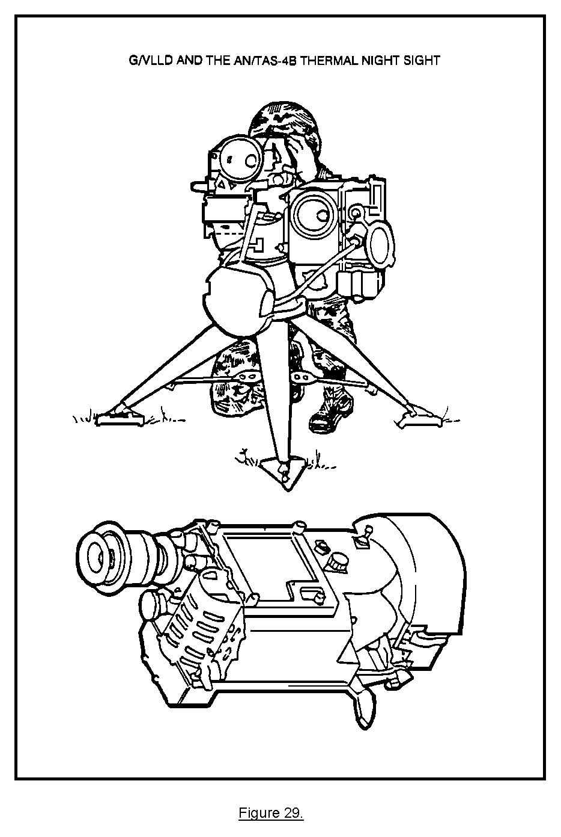
a. No matter how slight, the terminal night sight can pick up the difference in temperature within the target area. Hot metallic targets, such as a vehicle that has its engine running or has a weapon that has recently been fired, show up very clearly in the night sight. Even objects that collect heat or have been exposed to direct sunlight during the day can be detected by the night sight. A night sight reticle image showing the IR picking up a warm object is shown in Figure 30.
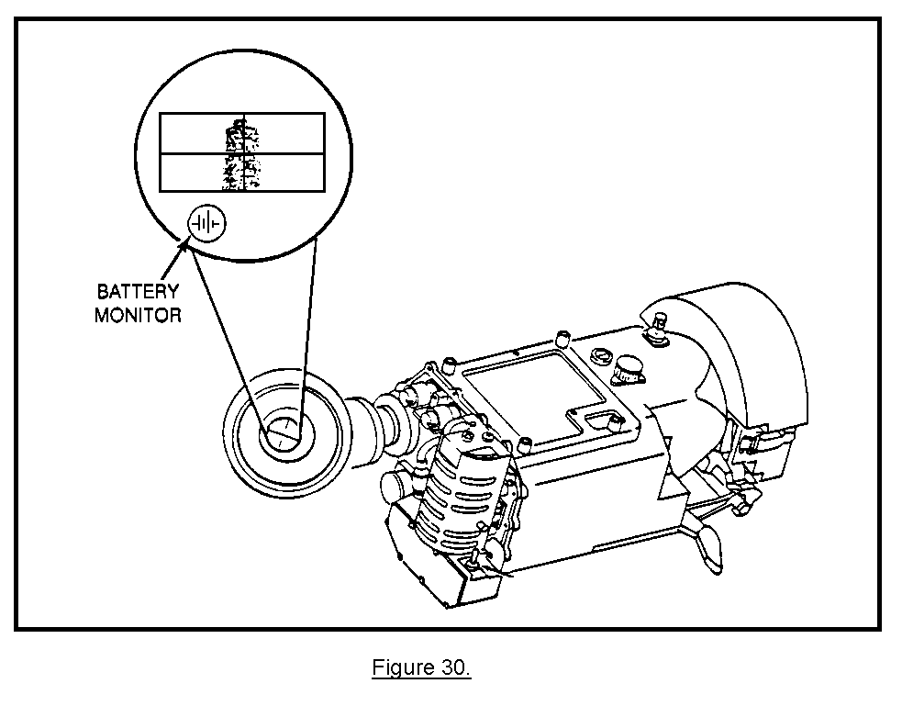
b. The thermal night sight is a precision instrument that must be handled with care. For the night sight to detect the difference in temperatures between objects, the IR sensor inside the night sight must be kept very cold. To keep it cold, the night sight employs a closed-cycle cooling system. While you are operating the night sight, the cooling system blows compressed air around the night sight IR sensor (Figure 31).
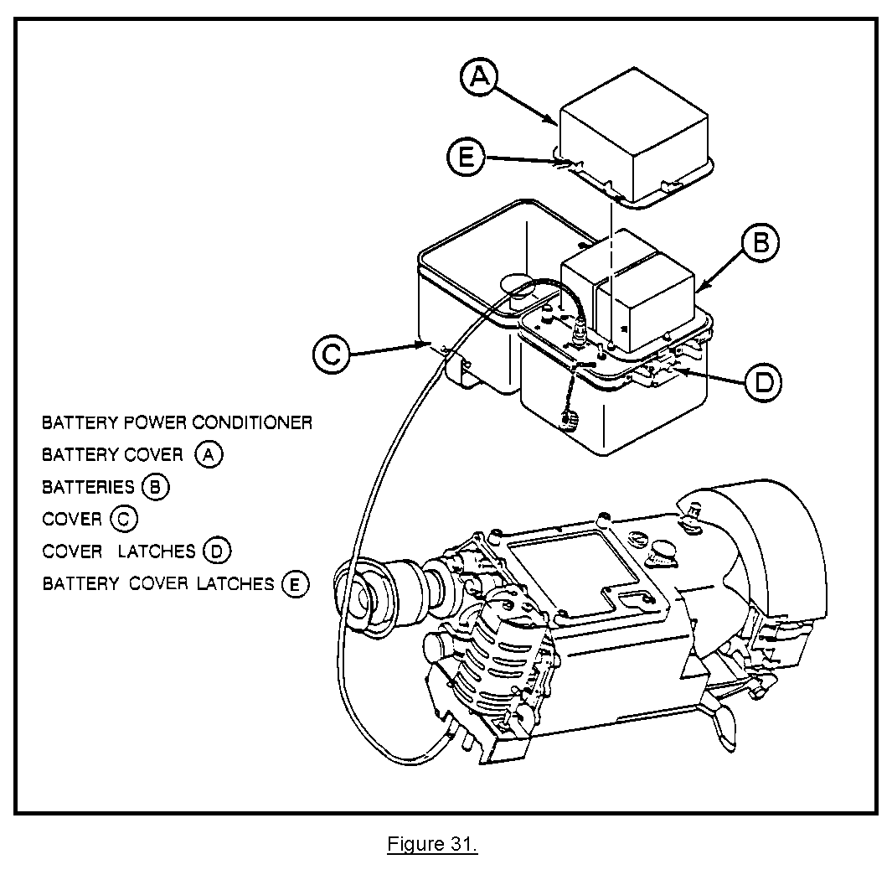
15. CHECKING THE NIGHT SIGHT. Before the night sight is used, perform the following (see Figure 32):

• Set the ON-OFF-STBY switch to STBY A . The cooler should run continuously for 160 seconds and then shuts off.

NOTE: The cooler cycles off for 100 seconds--then on for 20 seconds. The night sight can still be operated in the ON position if the STBY mode does not work. Continue with the checkout procedure, and have the night sight checked by support maintenance at the earliest possible date.

• Set the ON-OFF-STBY switch to ON, and sight through the eyepiece B. If the battery monitor is not lit but the reticle is lit, remove and replace the battery.

• To adjust the focus of the reticle in the eyepiece, rotate the diopter adjustment ring C until the focus is sharp and clear.

• Adjust the BRT control D for best focus of displayed image.

• Adjust the CTRS control E for best focus of displayed image.

• Adjust the field of view selector F. Set the selector to WFOV, and use the field of view focus knob G to focus the displayed field of view.
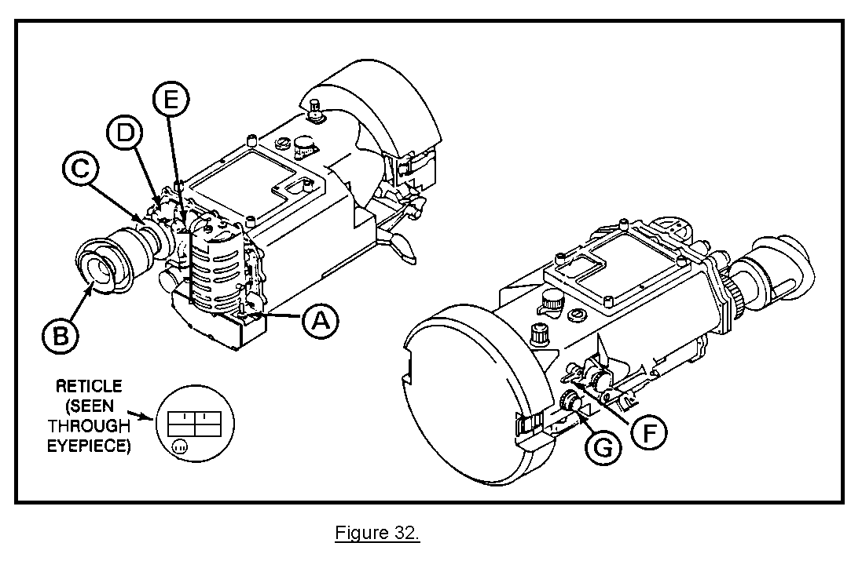
16. INSTALLING THE INTERFACE MOUNT AND NIGHT SIGHT. The AN/TAS-4B thermal night sight is designed to fit several different weapon systems, such as the M60 machine gun. When used with the G/VLLD, the night sight is attached to the traversing unit by using a device called an interface mount. The interface mount provides a stable platform for the night sight. (See Figure 33.) The night sight is a delicate optical instrument, and you must use care when installing the sight. The lenses on the sight are protected by an eyepiece cover and a canvas protective lens cover. Leave the covers installed on the sight until you are ready to test the IR system.
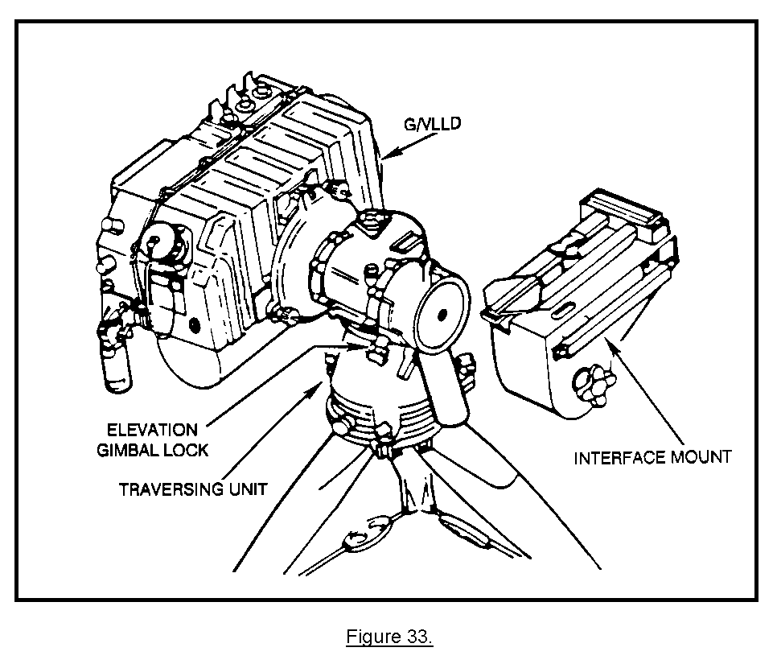
a. The first step for installing the interface mount and the AN/TAS-4B night sight is to position the traversing unit. To do this, you must ensure that the traversing unit (TU) handgrip has been rotated down and that the elevation gimbal lock is finger tight. This positions the traversing unit to enable you to install the interface mount to the circular mounting surface of the traversing unit (Figure 34). The locating pin on the traversing unit will be facing directly up, and the traversing unit must be locked firmly in place.
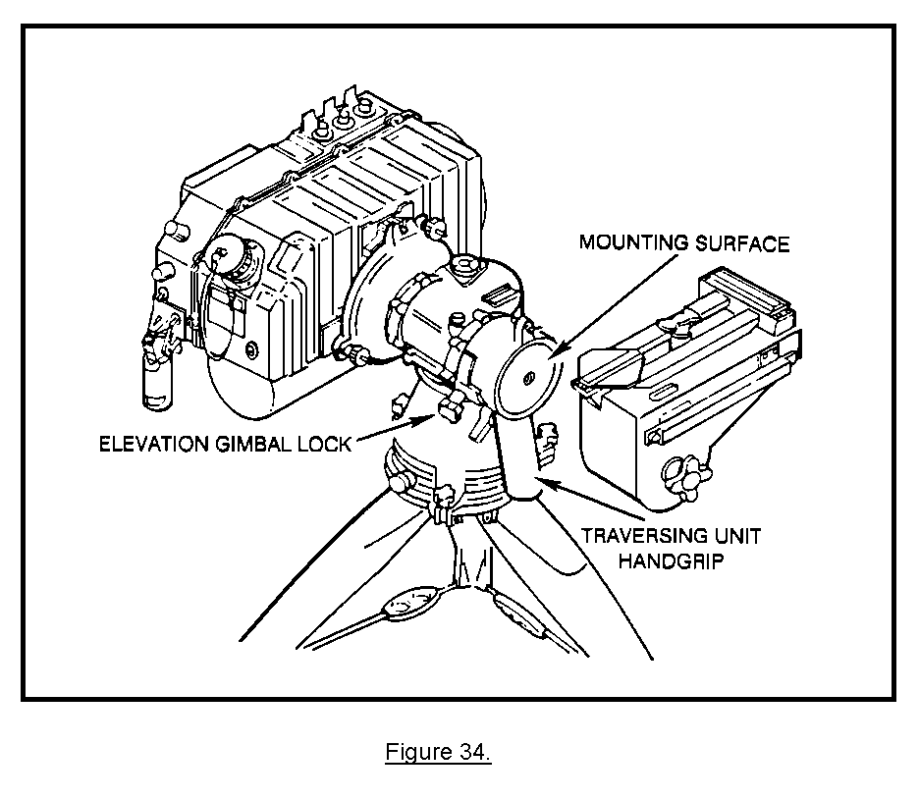
b. Next, you position the interface mount against the TU circular mounting surface. On top of the TU is a locating pin that must be engaged inside of the mount. This seats the interface mount firmly on the TU. Once the mount is in place, it must be secured by tightening the mounting screw into the hole in the center of the circular mounting surface. You can view the locating pin by looking through the hole on top of the night sight mount (Figure 35). The night sight mount must be firmly seated and secured to the traversing unit.
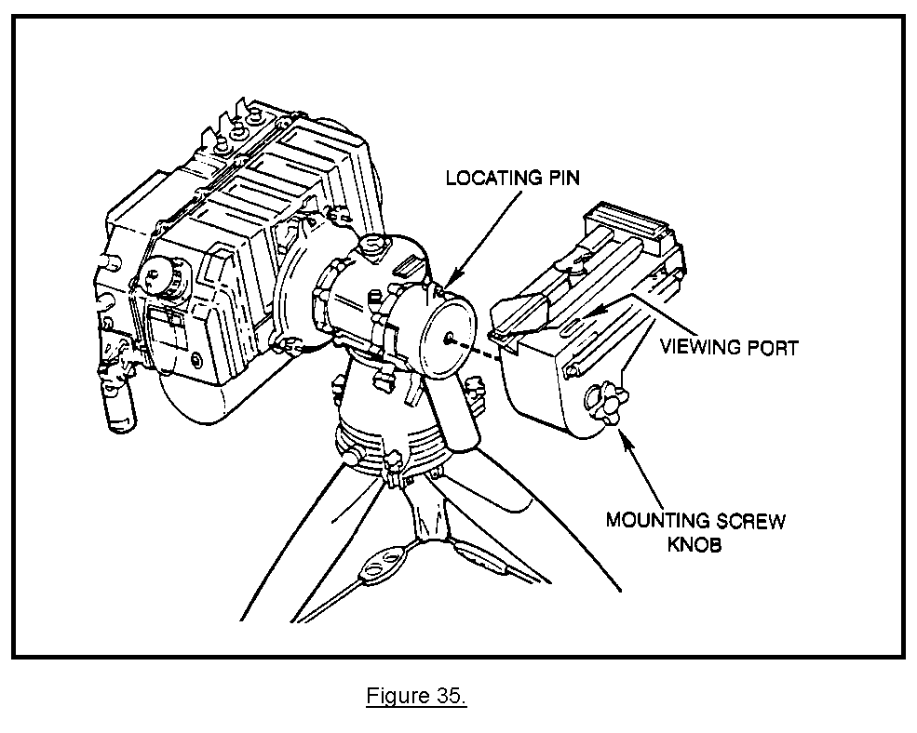
c. The next step is to use both hands and remove the night sight from its carrying case. When you remove the night sight, you must handle the sight carefully until you are ready to use the night sight. Leave the protective lens cover installed on the sight. (See Figure 36.) While holding the night sight, you pull the latch handle on the right side to the unlocked position. This opens the keyed hole on the bottom of the night sight so that it can be fitted onto the cam post on top of the mount. Look at the latch handle in Figure 37.
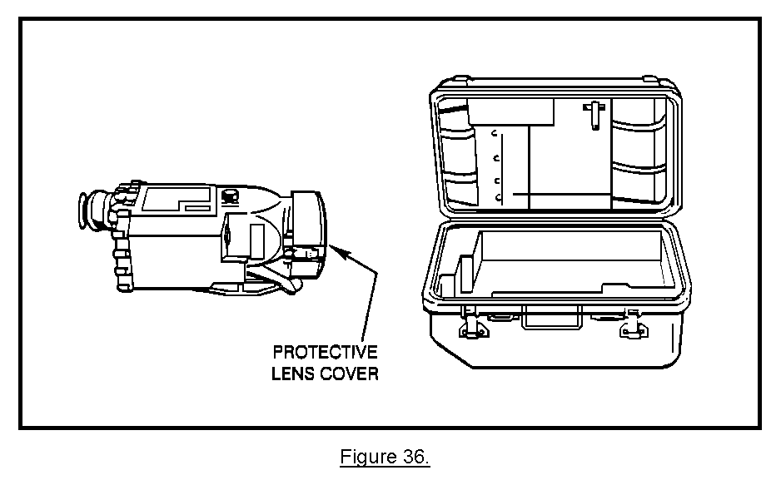
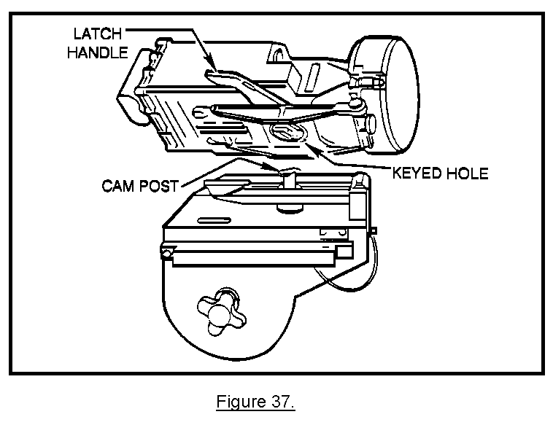
d. The next step you perform is to install the night sight on the night sight mount. To do this, you ensure the coarse azimuth knob on the front right is in position 2. This allows the night sight and night sight mount to align properly. (See Figure 38.)

(1) To install the night sight on the mount, perform the following:

• Rotate the coarse azimuth knob to position 2.

• Align the night sight with the V blocks and cam post.

• Lower the night sight into position.

• Ensure the night sight is firmly seated on the mount.
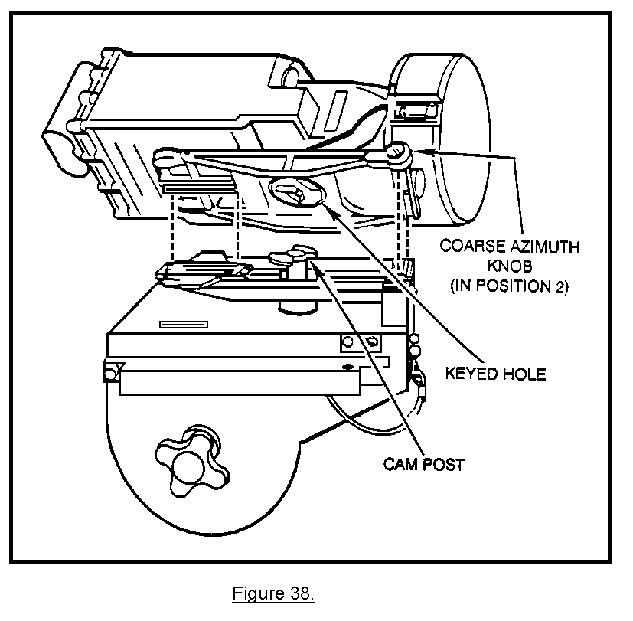
(2) Once the night sight is firmly seated on the mount, you secure the sight by moving the latch handle to the locked position (Figure 39). After the sight is secured, you check the bubble level on top of the traversing unit and make sure the tripod/traversing unit is still fine-leveled.

e. The last step to perform is to set the ON-OFF-STBY switch to the OFF position.
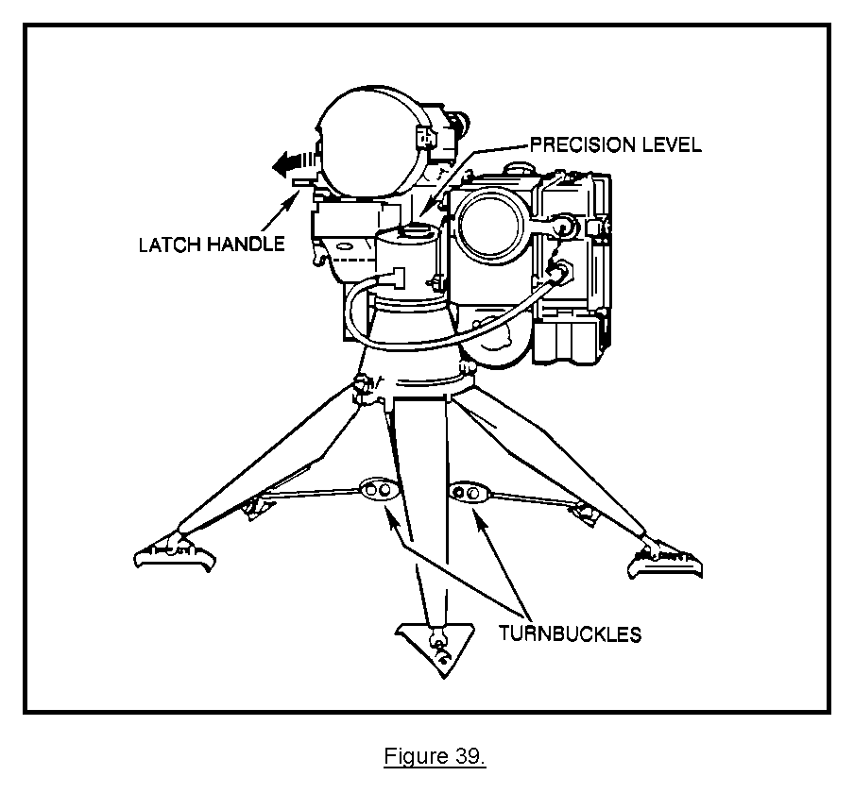
PRACTICE EXERCISES:

11. Look at the illustration below, and determine what must be done to the traversing unit to install the interface mount.

a. The LD/R handgrip should be rotated up and over the POWER switch.
b. The azimuth gimbal lock must be loosened, and the traversing unit should be swiveled toward the sector of fire.
c. The traversing unit handgrip should be rotated down, and the elevation gimbal lock should be tightened.
d. The LD/R should be removed from the traversing unit.
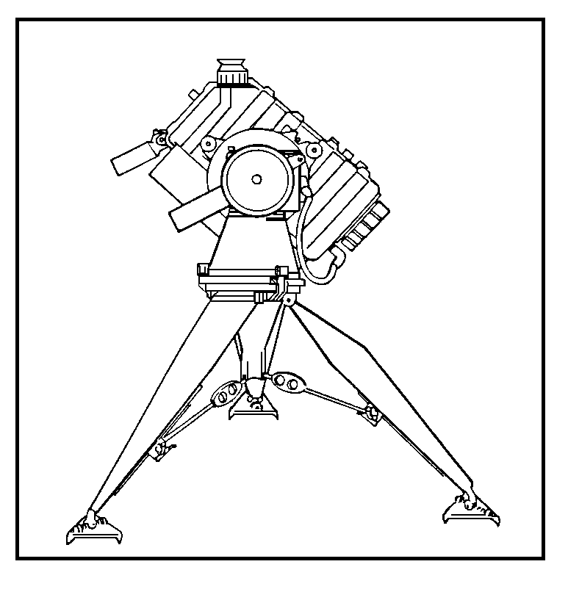
12. The illustration below shows the interface mount has been seated on the traversing unit circular mounting surface. What action must be performed to secure the mount to the traversing unit?

a. The mounting screw must be screwed into the hole in the center of the circular mounting surface.
b. The traversing unit handgrip should be rotated up.
c. The latch handle must be pushed forward.
d. The night sight should be installed on top of the mount so that the mount will not slip.

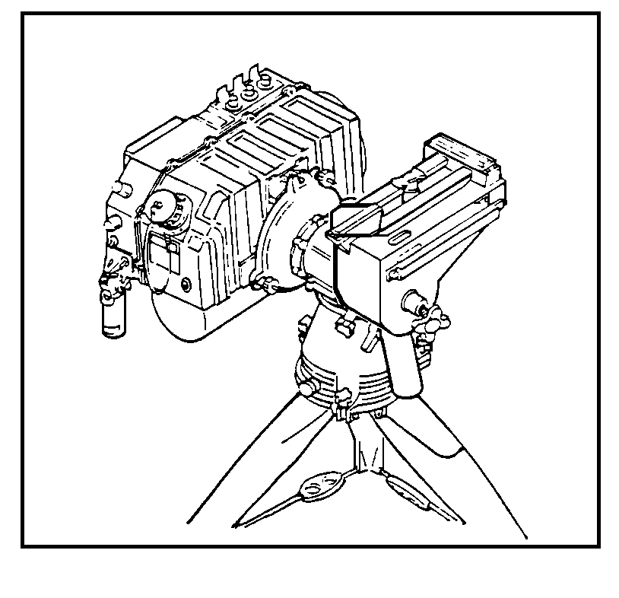
13. What must be done to the night sight before the cam post can be engaged in the keyed hole on the night sight?

a. The ON-OFF-STBY switch must be in the OFF position.
b. The latch handle must be pushed forward.
c. The latch handle must be pulled to the rear of the sight.
d. The cam post must be rotated counterclockwise.

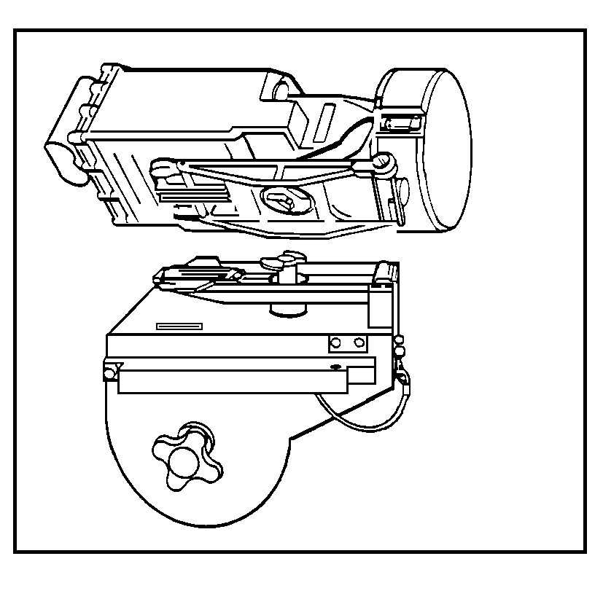
14. Look at the illustration below. Which of the following actions must be performed before fitting the night sight onto the mount?

a. The coarse azimuth knob must be turned to position 2.
b. The lens cover should be removed.
c. The ON-OFF-STBY switch should be set to ON.
d. The coarse azimuth knob should be turned to position 1.
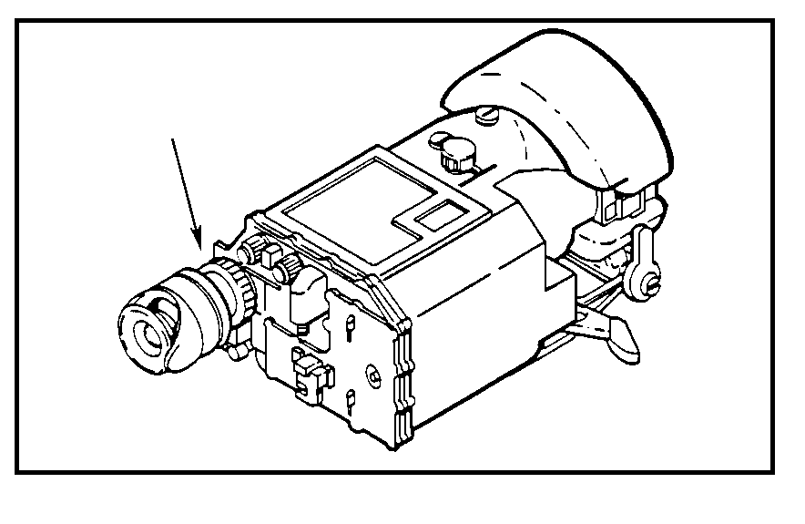
ANSWERS:

11. c.
12. a.
13. c.
14. a.

17. CHECKING THE NIGHT SIGHT BATTERY. Like the G/VLLD, the AN/TAS-4B night
sight can be run from either vehicle or battery power. In this lesson, we will only be concerned with the battery power. The night sight battery must be checked to see if it is fully charged and functioning properly. The NICAD battery can loose its charge; therefore, you must check the condition of the battery before use. Look at Figure 40. The battery monitor can be seen by looking through the eyepiece. If the reticle is lit and the battery monitor is not lit, then you should remove and replace the two batteries.

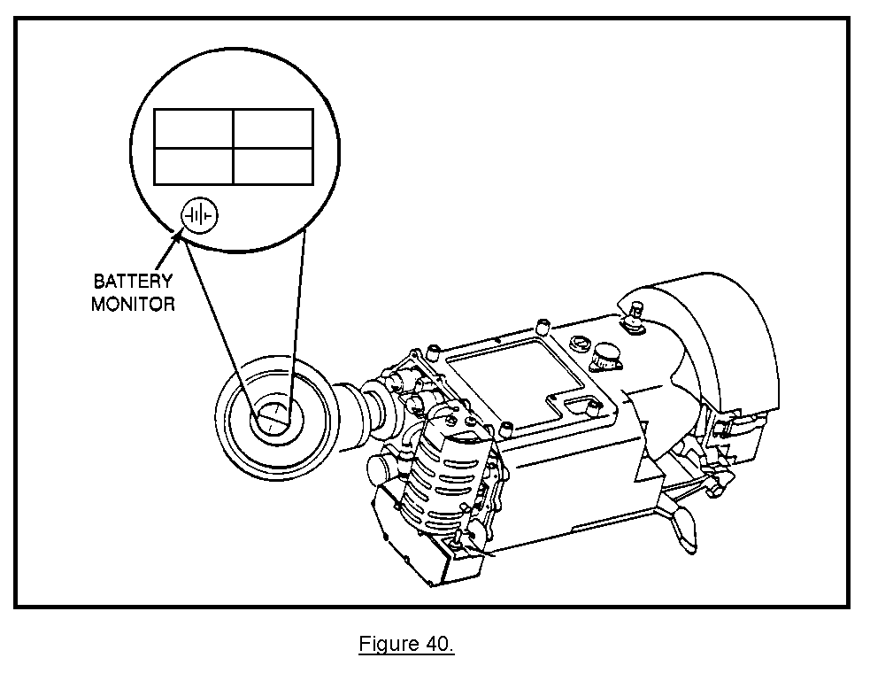
18. ADJUSTING THE NIGHT SIGHT FOR VIEWING. Once you have determined that the close-cycle cooling system and the batteries are functioning properly, you need to adjust the night sight controls for normal viewing and both narrow field of vision (NFOV) and wide field of vision (WFOV).

a. With the night sight, there are two ways to observe the battlefield. Normally, you will use WFOV to scan the battlefield as you look for targets. Once you have located a target, you can enlarge the image by using the NFOV function. Each time you switch from WFOV to NFOV, you must check the brightness and contrast of the image through your eyepiece. There are two knobs you can use to control brightness and contrast. These are the BRT control and the CTRS control.

b. The other controls you use to properly focus the image are the diopter ring and the range focus knob. (See Figure 41.)

c. Select a suitable scene for viewing. You can select a definable object that is emitting heat--a rock formation or metal object will be fine. By looking through the eyepiece, you can adjust contrast and brightness on the image.

d. Now you adjust two focus controls. One control is the diopter adjustment ring, which is the rotating collar around the eyepiece lens. The diopter adjustment ring focuses the night sight reticle image. The other focus control is the range focus control, which is located on the forward left side of the night sight. The range focus control brings your target into focus.

e. Once the images are clear, you set the field of view selector to WFOV for general observation. (See Figure 41.)

f. Since the batteries have a limited charge, you set the ON-OFF-STBY switch to STBY while not performing checks or observation. This preserves the power in the batteries for later use. The last thing to do is to replace the protective lens cover on the front of the night sight and put the canvas cover over it.
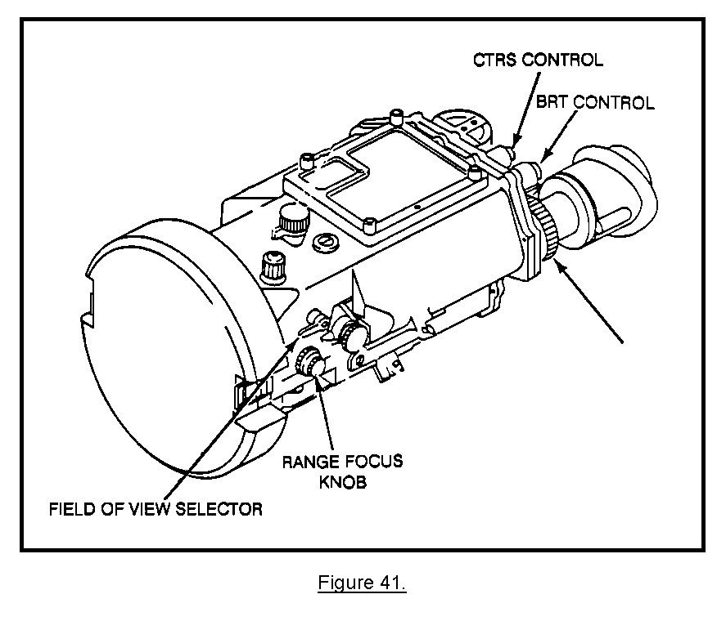
19. CORRECTING BORESIGHT ALIGNMENT. To ensure the night sight is aimed at the same target as the G/VLLD, use the boresight collimator. This is a device to locate the LD/R cross hairs and bring the night sight cross hairs on line with the collimator. Keep in mind the collimator is also a precision instrument and should be handled with care. (See Figure 42.)
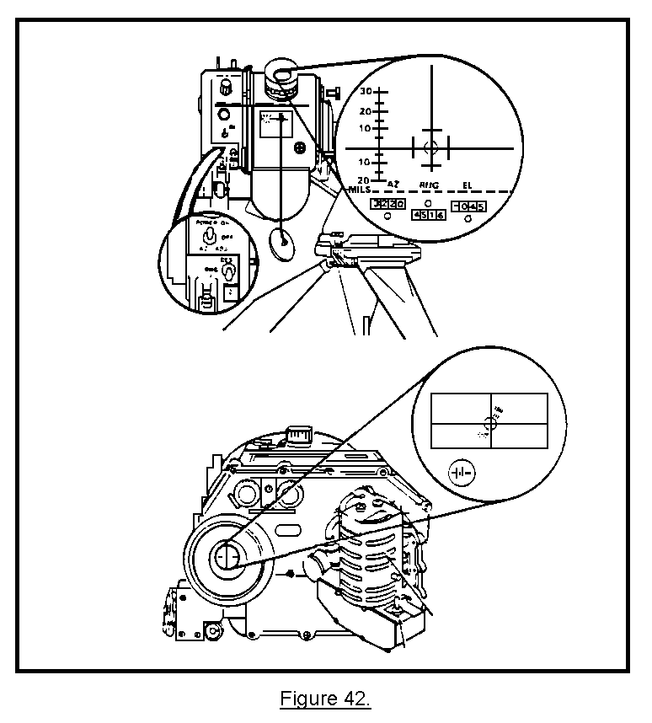
a. The night sight must be boresighted when any of the following conditions occur:

• When night sight is installed on interface mount.

• When operational temperature changes 40øF or more from that of last boresighting.

• After equipment has been subjected to rough treatment.

• When LD/R is replaced.

Once the boresight reticle has been centered on the LD/R cross hairs, you look through the night sight eyepiece and see how far the night sight is out of alignment. A boresight reticle will also appear on the inside of the night sight reticle. To align the night sight with the LD/R, adjust the azimuth and
elevation controls (Figure 43) on the night sight by exactly aligning the two reticles.
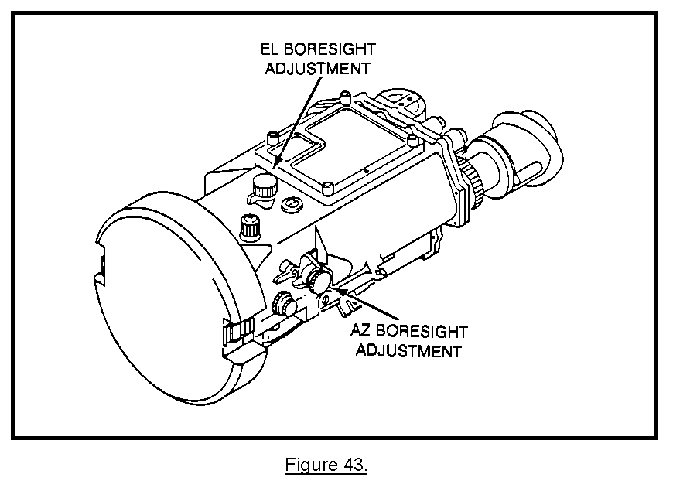
b. The following steps are used for performing a boresight alignment.

(1) The first step for performing a boresight alignment will be to remove the collimator from its case. The boresight collimator is a very delicate optical instrument; therefore, handle it carefully.

(2) Once the collimator has been removed, you look at the collimator mount and ensure that the adjustment ring has been set to GLLD. If it has not, you cannot fit the collimator to the G/VLLD. (See Figure 44.)
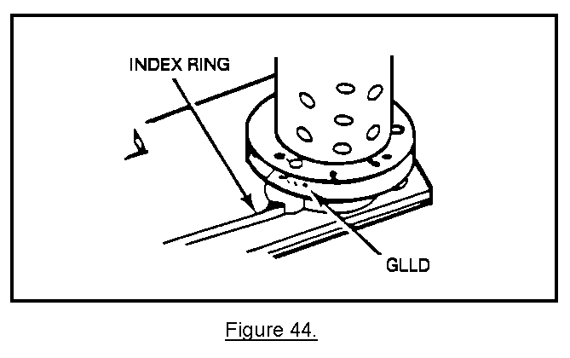
(3) The collimator must be removed from the case and the index ring must be set to GLLD (Figure 45).

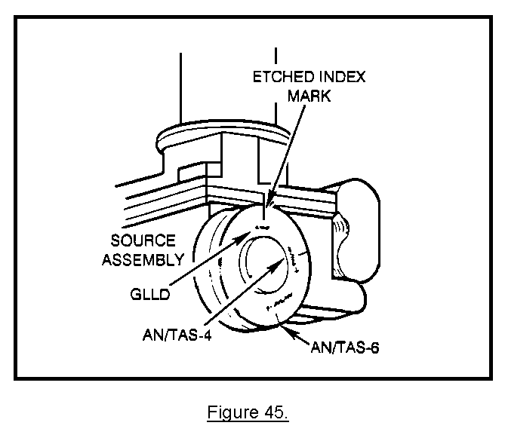
(4) Once you have inspected the boresight collimator, you need to install the collimator on the front right of the night sight and secure it in place. (See Figure 46.) After you have secured the collimator to the night sight, check on the right side of the sight and ensure the coarse azimuth knob is set to position 2.
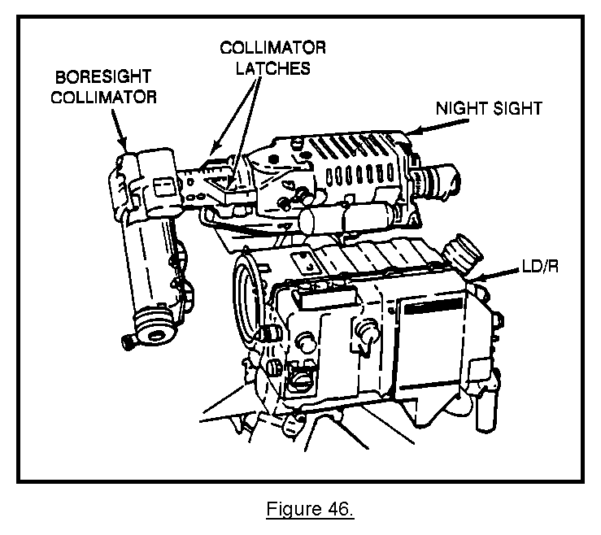
(5) The collimator comes equipped with a power cable; therefore, you need to connect the cable to the collimator and night sight. Set the ON-OFF-STBY switch to ON and the FOV selector to the NFOV position.

(6) Next, you attach the support bar to the TU. This support bar must be installed to prevent the LD/R and night sight from rotating forward while boresighting. (See Figure 47.)

(7) Next, you loosen the elevation gimbal lock. When loosening the elevation gimbal lock, take care to allow the night sight mount to slowly rest on the support bar. Do not relock the elevation gimbal lock. This will affect the accuracy of the boresight alignment.
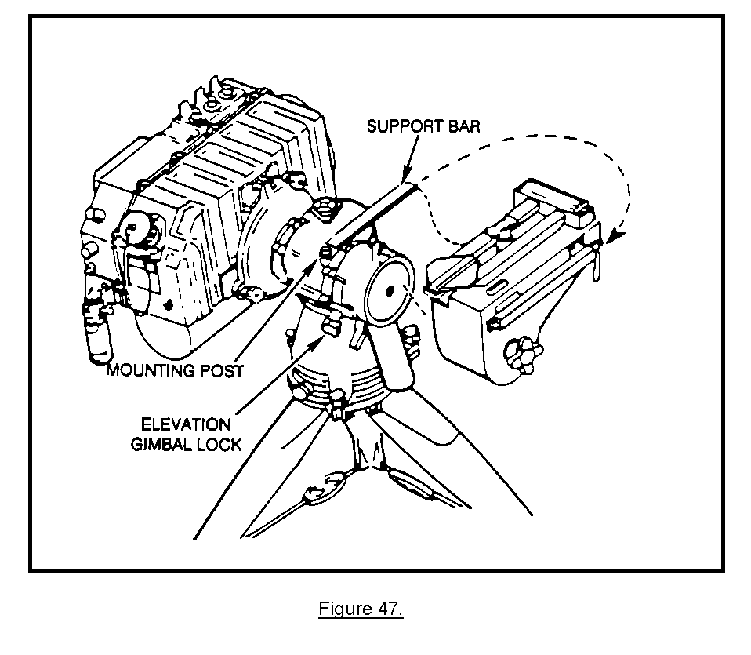
(8) Now you are ready to boresight the night sight. By looking through the LD/R eyepiece, you can see the collimator reticle overlay the LD/R reticle. Since the collimator is not aligned with the LD/R, the collimator reticle will probably appear off-center of the LD/R cross hairs. Next, you need to align the collimator reticle directly over the LD/R reticle. This is done by simply adjusting the collimator azimuth and elevation knobs on the front of the collimator. Figure 48 shows that all you need to do is center the night sight cross hairs over the collimator reticle.
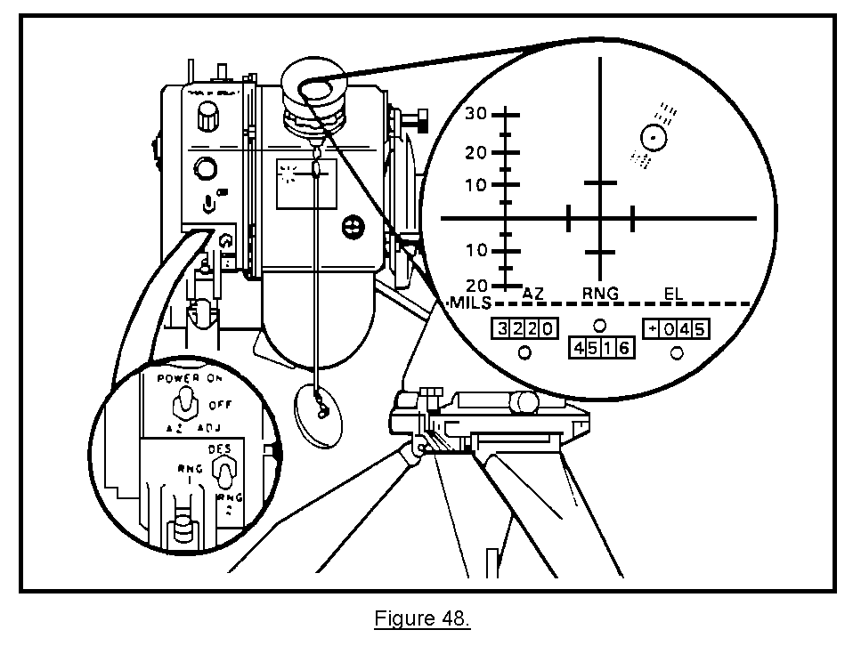
(9) The last thing you need to do before you are ready to operate the G/VLLD system is to store the support bar and turn off the night sight power. To release the pressure on the support bar, you must rotate the TU handle toward positive elevation.

20. SUMMARY. In this lesson, you have learned how to install the interface mount and night sight on the G/VLLD traversing unit. The night sight mount must be firmly seated and secured to the traversing unit before attaching the night sight. When unpacking the night sight, hold it in one hand and with the other pull the latch handle to the unlocked position. This will open the keyed hole on the bottom of the sight so that it will fit on the cam post on top of the mount. Also, the night sight must be boresighted each time the G/VLLD is moved from one position to another. Finally, to align the collimator reticle over the LD/R reticle, you must adjust the collimator azimuth and elevation knobs.

LESSON 4

CONNECT THE AN/TVQ-2 G/VLLD TO THE DMD

OBJECTIVE

Upon completion of this lesson, you will be able to connect the DMD to the G/VLLD.

REFERENCES

This lesson is based on FM 6-30 and other materials approved for US Army field artillery instruction; however, development and progress render the text continually subject to change. Therefore, base your examination answers on material presented in this subcourse rather than on individual or unit experience.

21. INTRODUCTION.

a. As the field artillery fire direction control radio nets became more and more crowded, the FO needed a quick and clear means of communication with the FDC. The DMD fulfills this need. The G/VLLD has been designed so that the DMD can be connected to it within a matter of seconds. This allows the FO to communicate with the FDC without using the voice networks.

b. The DMD is a highly versatile communications device that can be used with almost any military radio. When used with the G/VLLD, the DMD can be connected to the G/VLLD and then to a radio. In this mode of operation as the G/VLLD lases a target, the range azimuth and vertical angle readings are displayed on the DMD display. Once the FO has checked the information and made the proper entries in the call-for-fire format, the information can be instantly transmitted directly to the tactical fire direction system (TACFIRE) or a battery computer system (BCS) in the fire direction center.

NOTE: You will learn how to adjust fire with the G/VLLD when using a DMD in a later lesson. In this lesson, you will learn how to connect the DMD to the G/VLLD. You will be lead step-by-step through the procedures for connecting the DMD to the G/VLLD as if the G/VLLD is actually sitting in front of you. As you go through the steps, study the illustrations and visualize exactly what you will be expected to do.

22. CONNECTING THE DMD TO THE G/VLLD. This can be a very simple procedure, which you will be able to do rapidly once you have become familiar with the task.

a. The DMD is connected to the G/VLLD by the use of a 3.7-meter electrical cable with connectors on each end. The connector plugs on the cable are very delicate. Take special care not to damage the prongs inside the plug. (See Figure 49.)
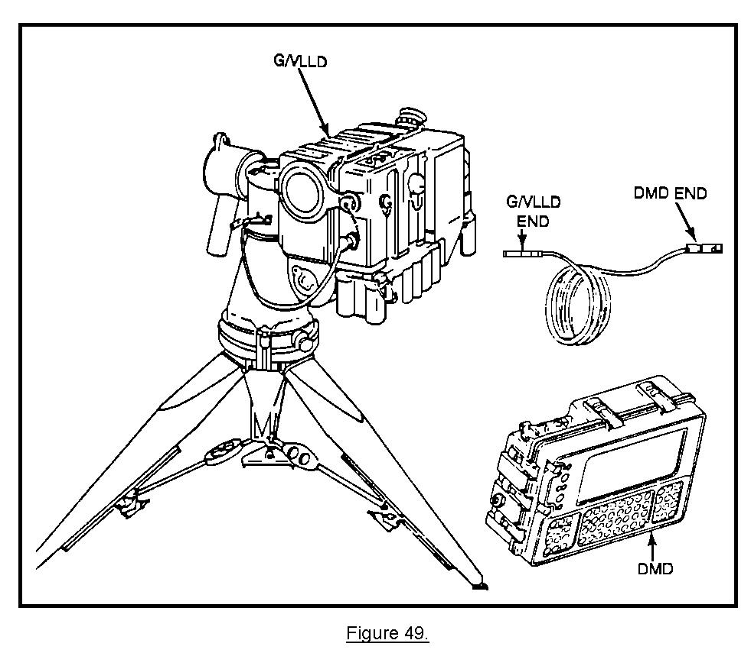
b. The plugs on opposite ends of the cable assembly are made slightly different from each other so that the cable can be attached to the G/VLLD and the DMD. Each plug is clearly marked "DMD" and "G/VLLD." When you are installing the cable assembly, make sure you attach the proper plug to the DMD and G/VLLD connectors. To install the cable assembly, perform the following steps in the order they appear:

• Locate the power EXT-OFF-INT SWITCH on the left side of the DMD (Figure 50).

• Move the toggle switch to the OFF position.

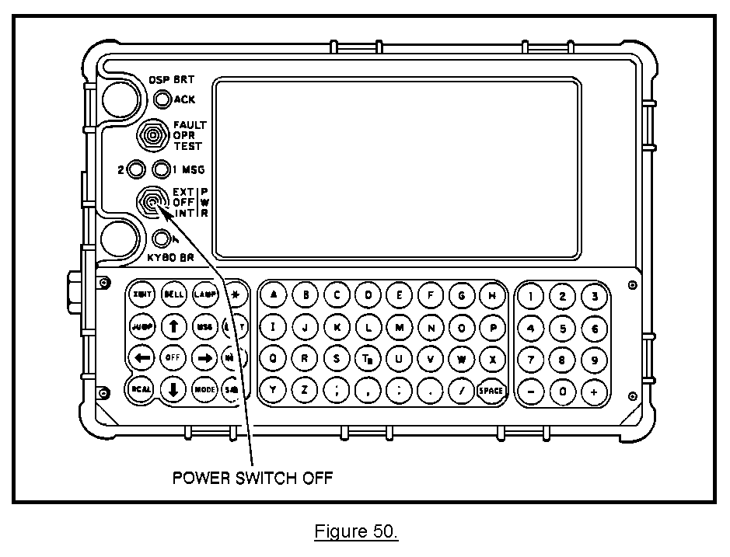
• Uncoil the cable, and find the end of the cable marked "DMD" (Figure 51).

• Remove the rubber dust cover on the center post marked G/VLLD.

• Take the cable assembly, and locate the plug labeled "DMD."

• Connect the DMD plug on the cable assembly onto the G/VLLD connector.

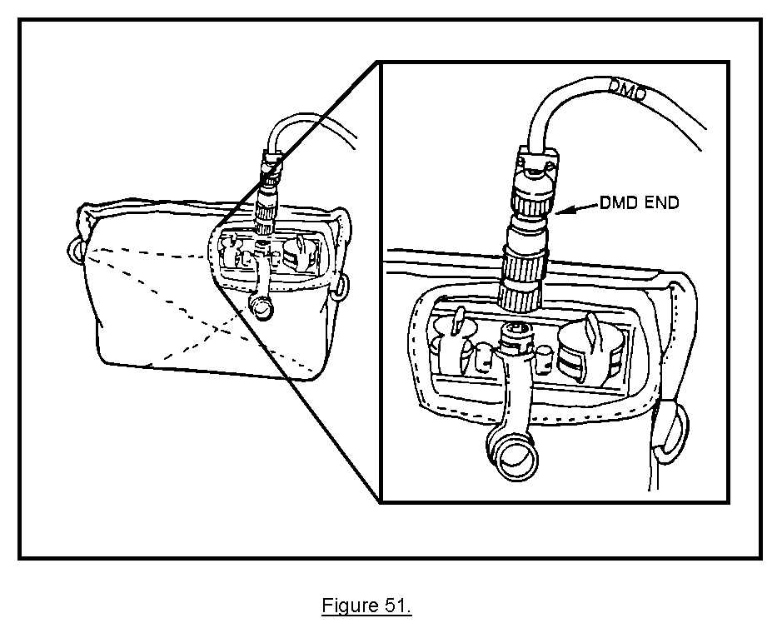
• Locate the 1J4 connector on the front left-hand side of the LD/R (Figure 52).

• Turn the metal cover counterclockwise, and let it hang by its metal chain. The 1J4 connector on the G/VLLD is now exposed.

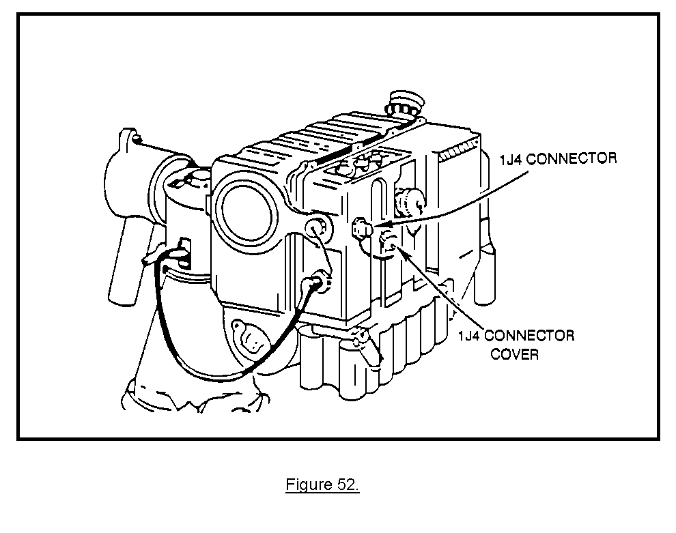

• Locate the plug labeled "G/VLLD" on the cable assembly.

• Push and lock the G/VLLD plug onto the 1J4 connector.

• Turn the G/VLLD plug retaining collar clockwise until it is finger tight (Figure 53). The DMD is now properly cabled to the G/VLLD.

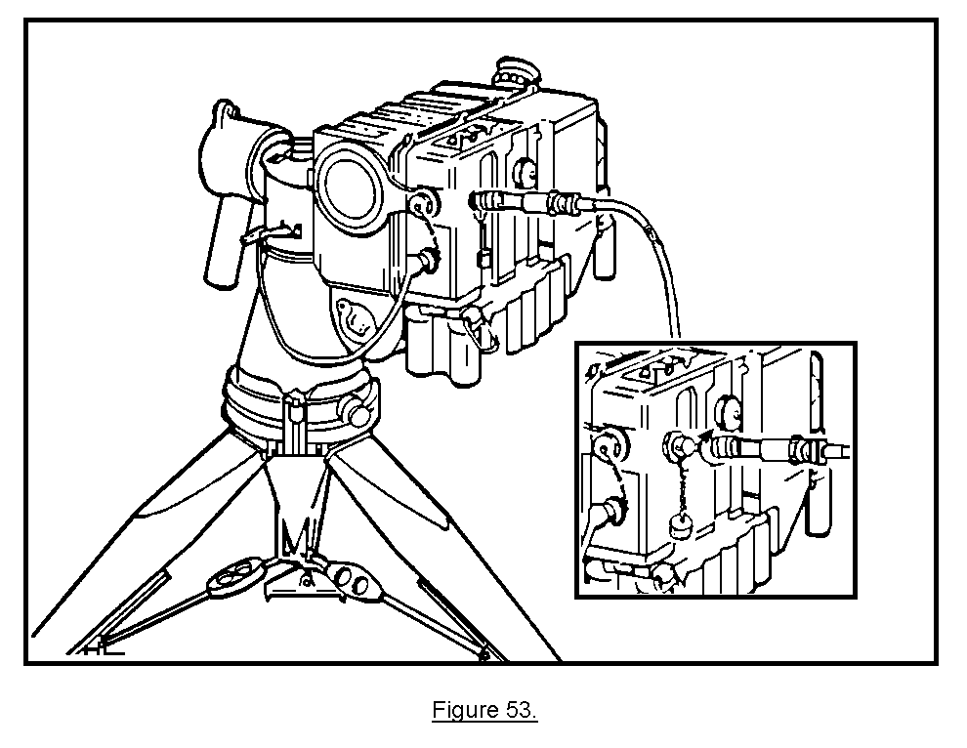
PRACTICE EXERCISES:

15. Look at the illustration below. The cable assembly has been connected to the DMD. What is the next operator action?

a. Connect the cable to the interface connector.
b. Connect the cable to the G/VLLD battery.
c. Remove the 1J4 connector cover.
d. Turn EXT-OFF-INT switch on the DMD to EXT.
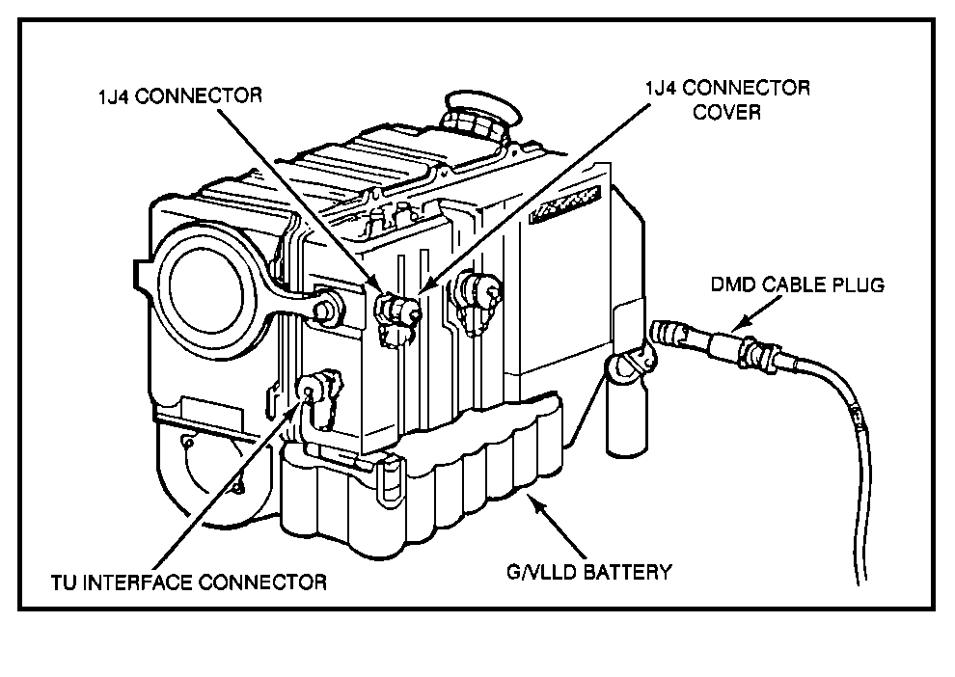
16. Before connecting the cable assembly to the DMD, you should set the power switch to which position? (See the illustration below.)
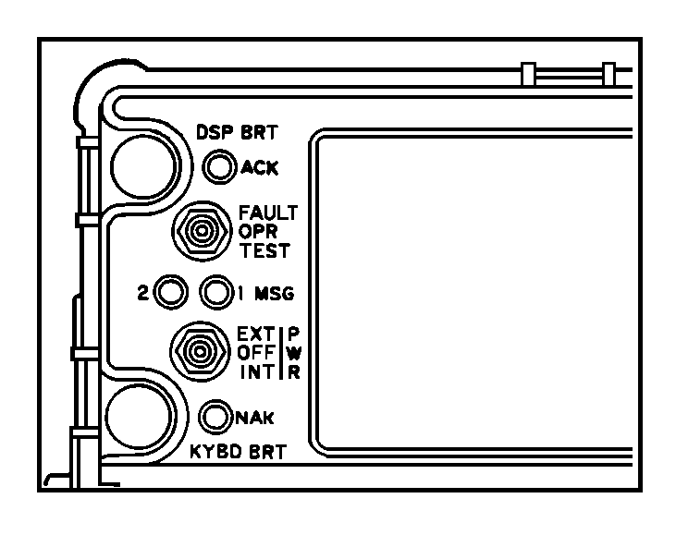
ANSWERS:

15. c.
16. OFF position

23. SUMMARY. The observer has radio communications with the FDC, and at times, he might have land line. However, with the use of the DMD, he can communicate with the FDC without fear of his transmission being jammed by the opposing force. The DMD is a highly versatile device that can be used with almost any military radio. It can be connected to the G/VLLD within a matter of seconds. Once the observer has checked the information in the call-for-fire format, it is transmitted instantly to the TACFIRE or BCS in the fire direction center.

